1. What are Confidence Intervals



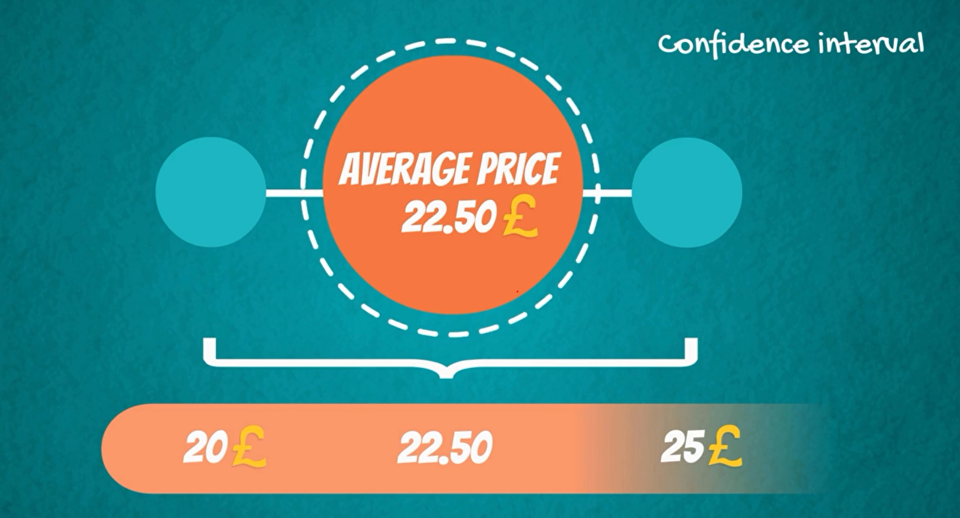

confidence interval is a much more accurate representation of reality

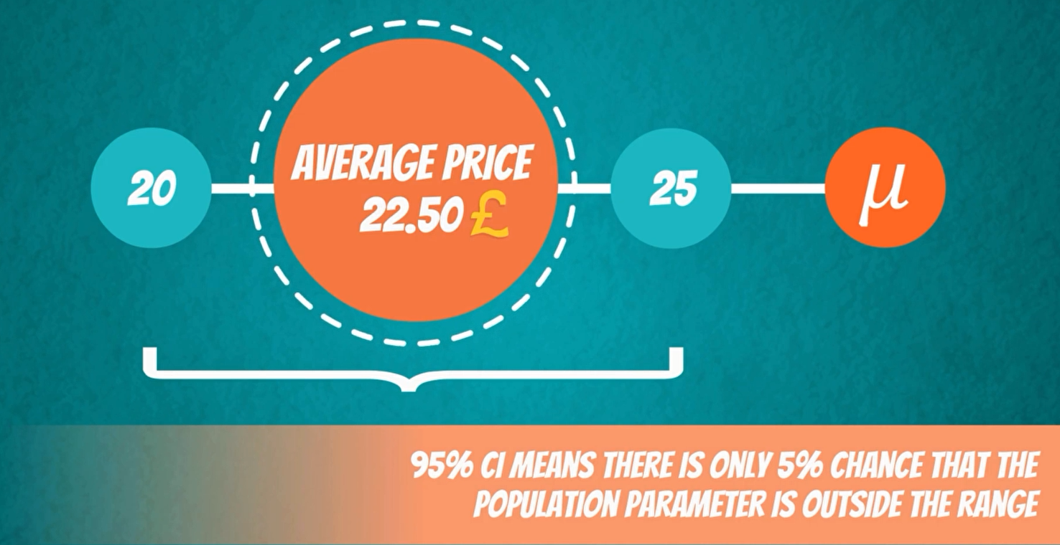

The level of confidence it is denoted by 1 minus Alpha and is called the confidence level of the interval. alpha is a value between 0 and 1

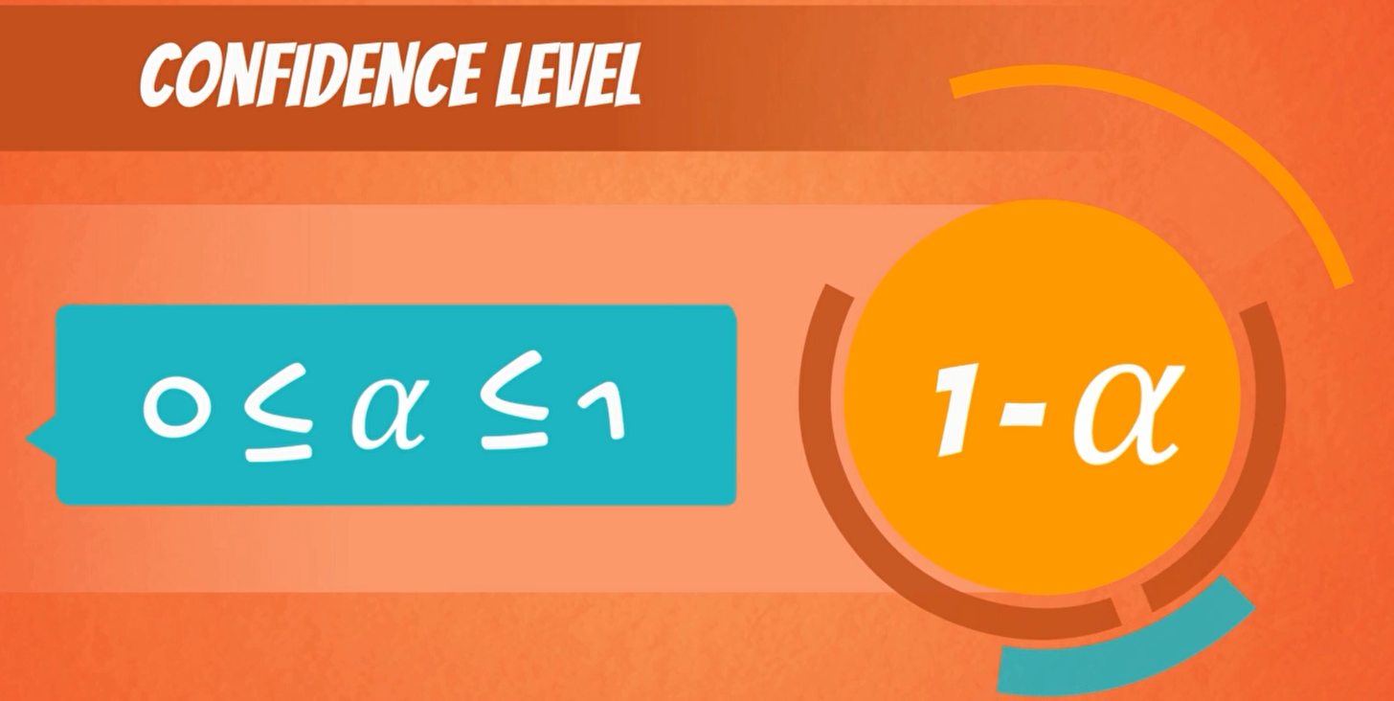

Example of confidence Interval

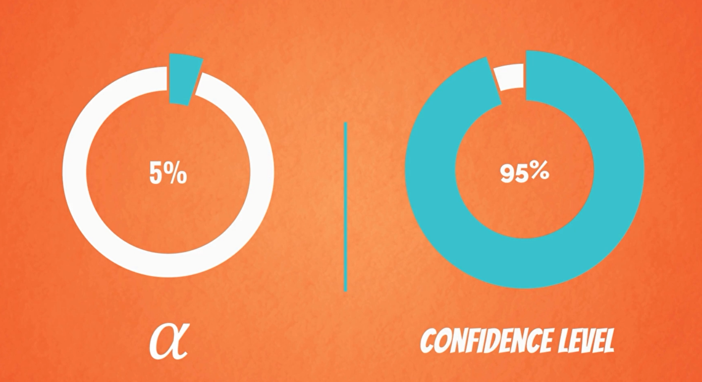

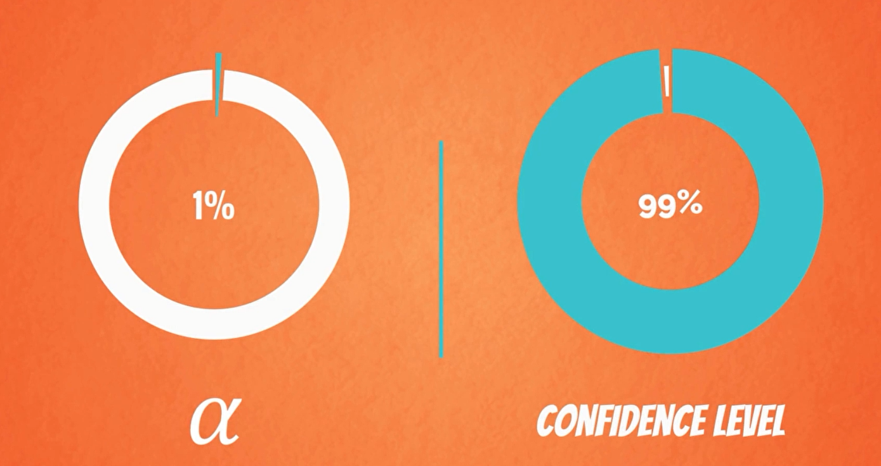

The formula for all confidence interval

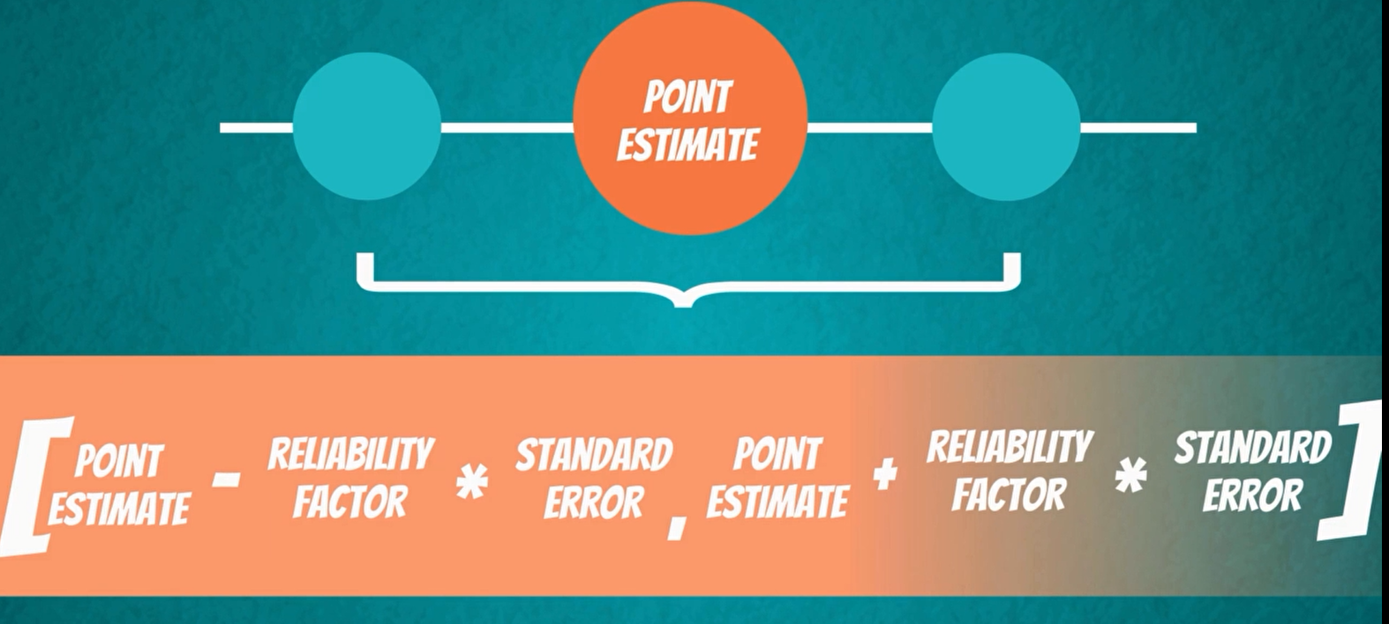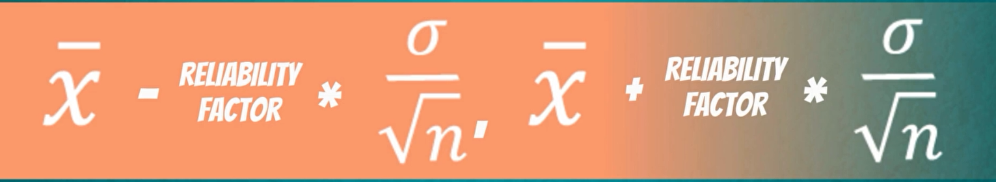

1. Confidence Intervals; Population Variance Known; z-score

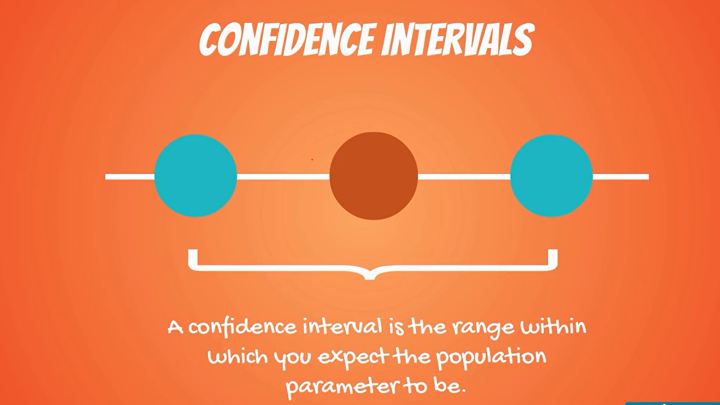

Sample mean

**Confidence Interval**

The sample mean is the point estimate.

Its estimation is based on the data we have in our sample

There can be two main situations when we calculate the confidence intervals for a population where

1. the population barrier is known and
2. when it is unknown

depending on which situation we are in. we would use a different calculation method.

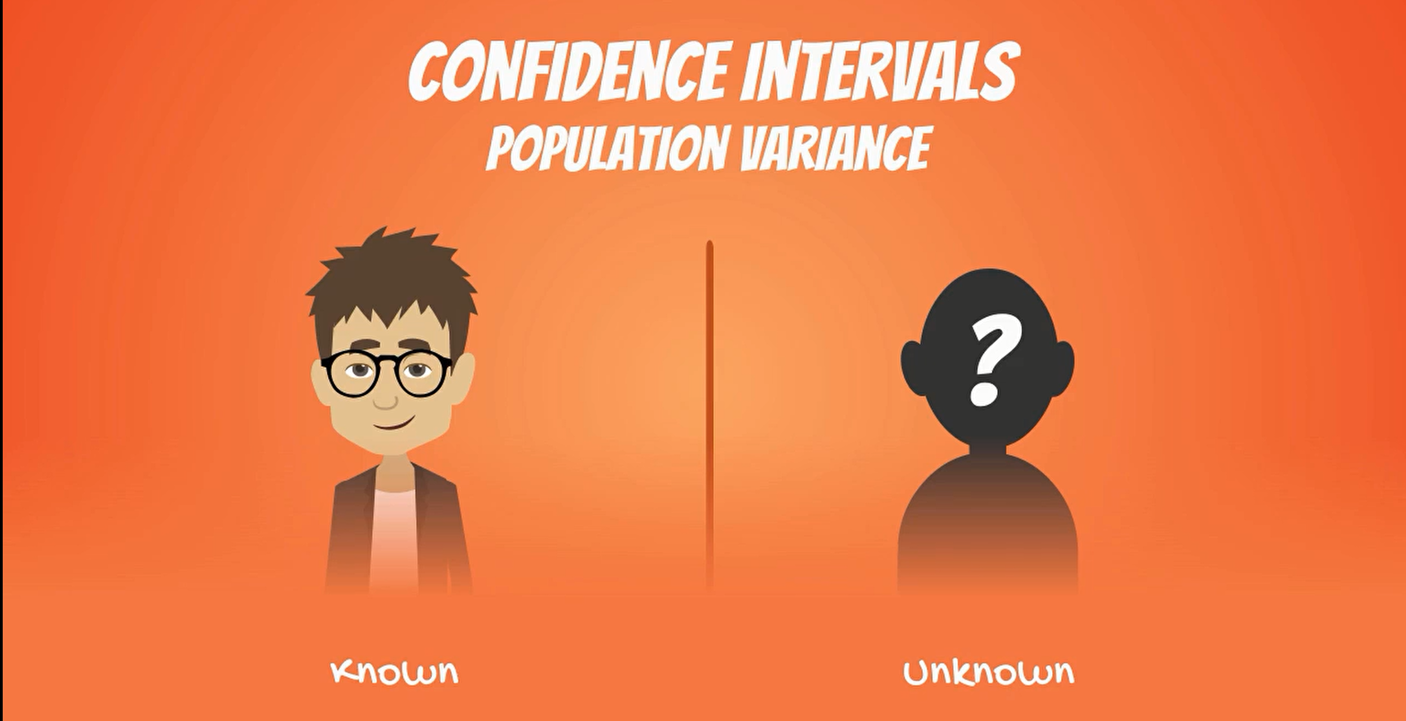

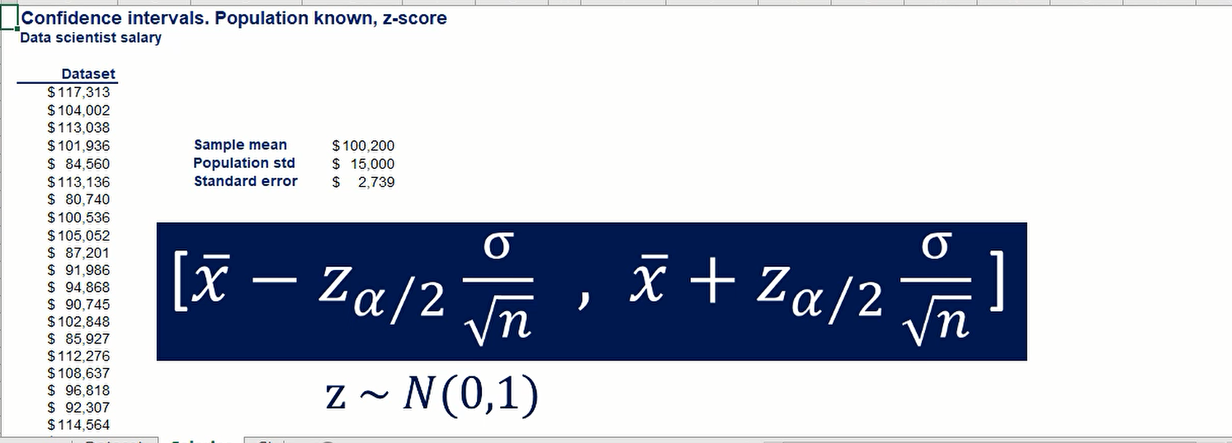

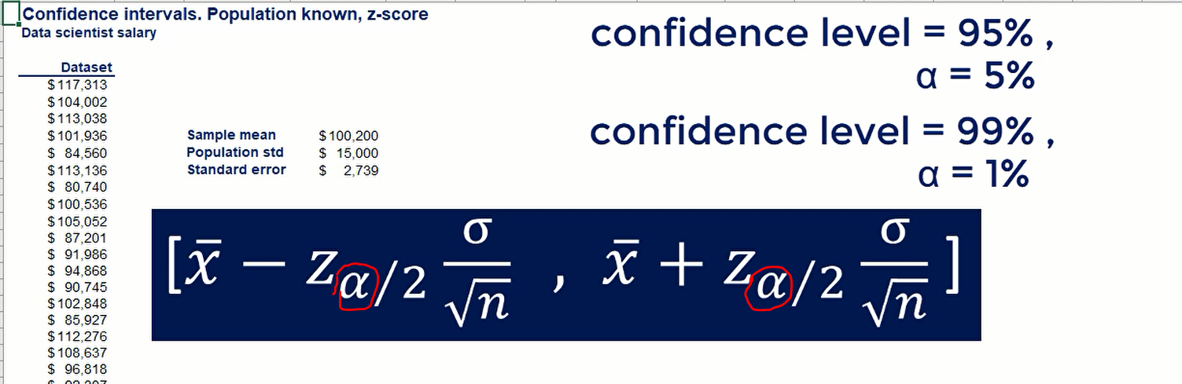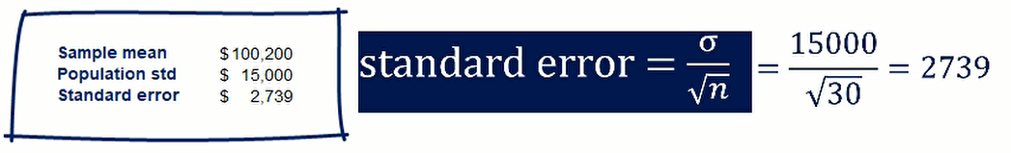

Sample size n=30

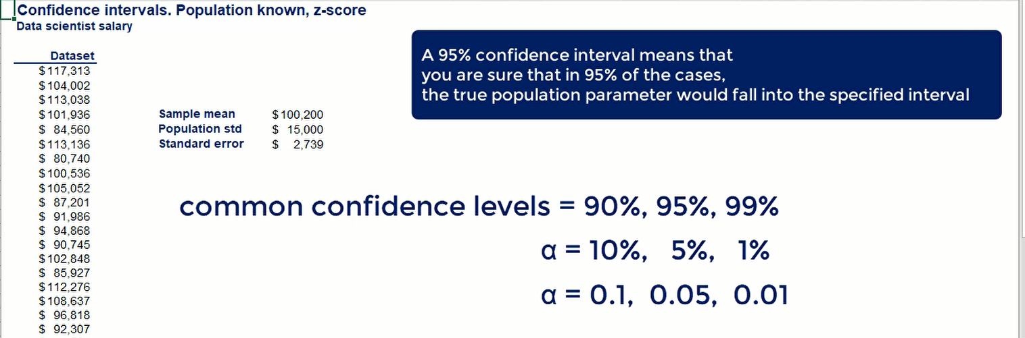

**Z of Alpha**

The z of Alpha comes from the so-called standard normal distribution table.

let's say that we want to find the values for the 95% confidence interval Alpha is zero 0.05.

**Standard normal distribution Z table**

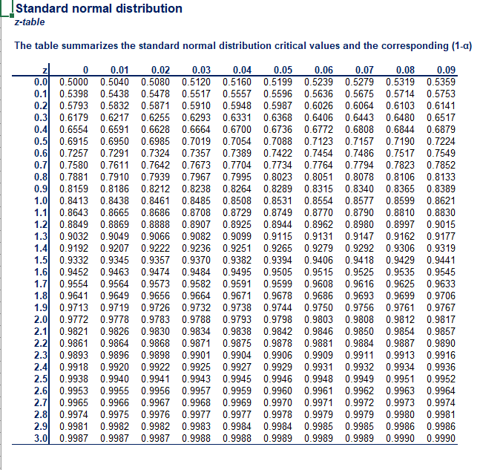

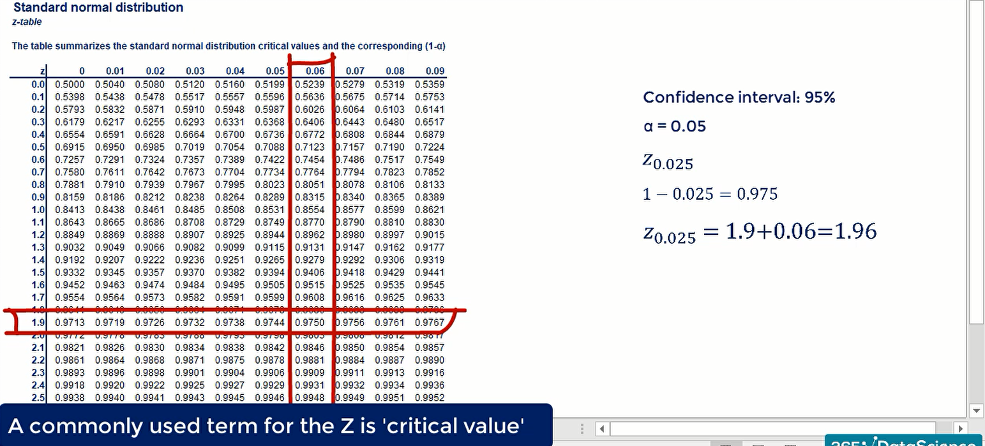

z comes from the sum of the row and column table headers.

**Confidence Interval**

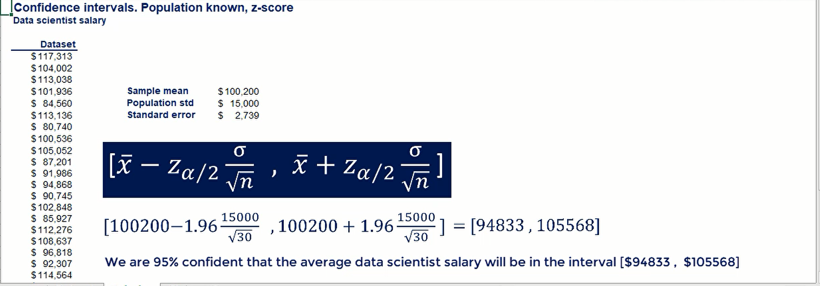

Figure: 95% Confidence Interval

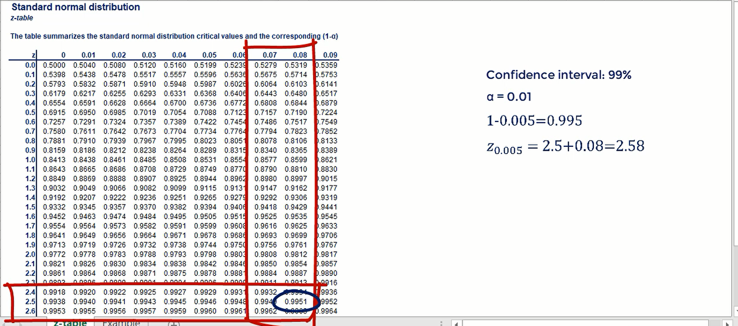

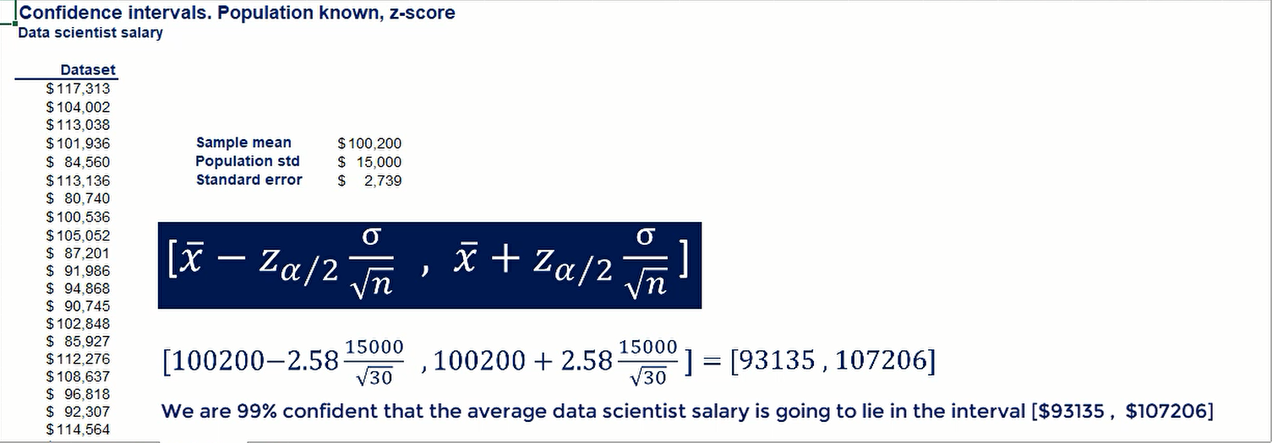

Figure: 99% Confidence Interval

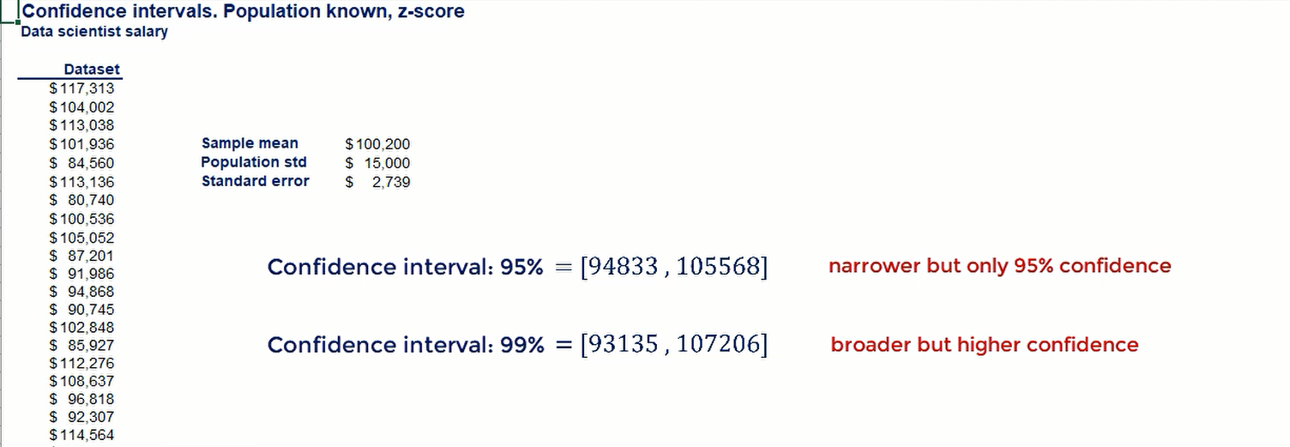

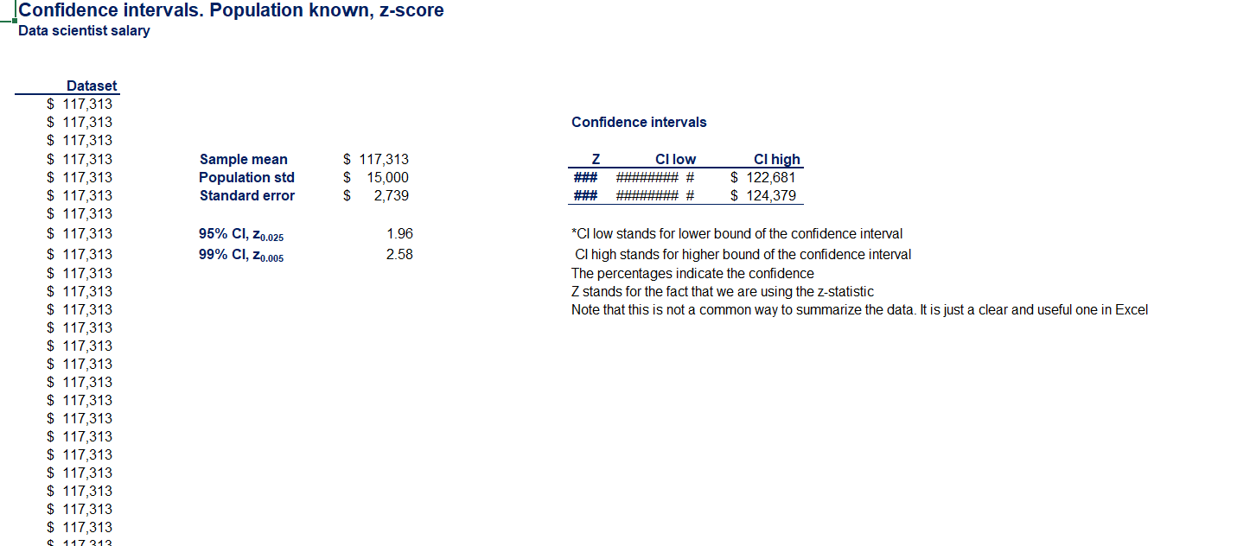

5. Confidence Interval Clarifications

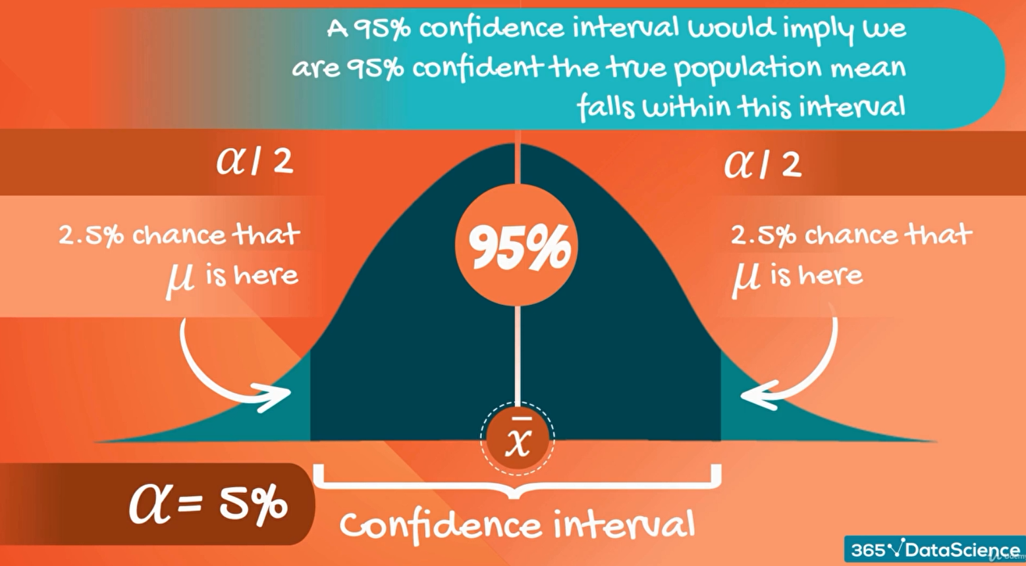

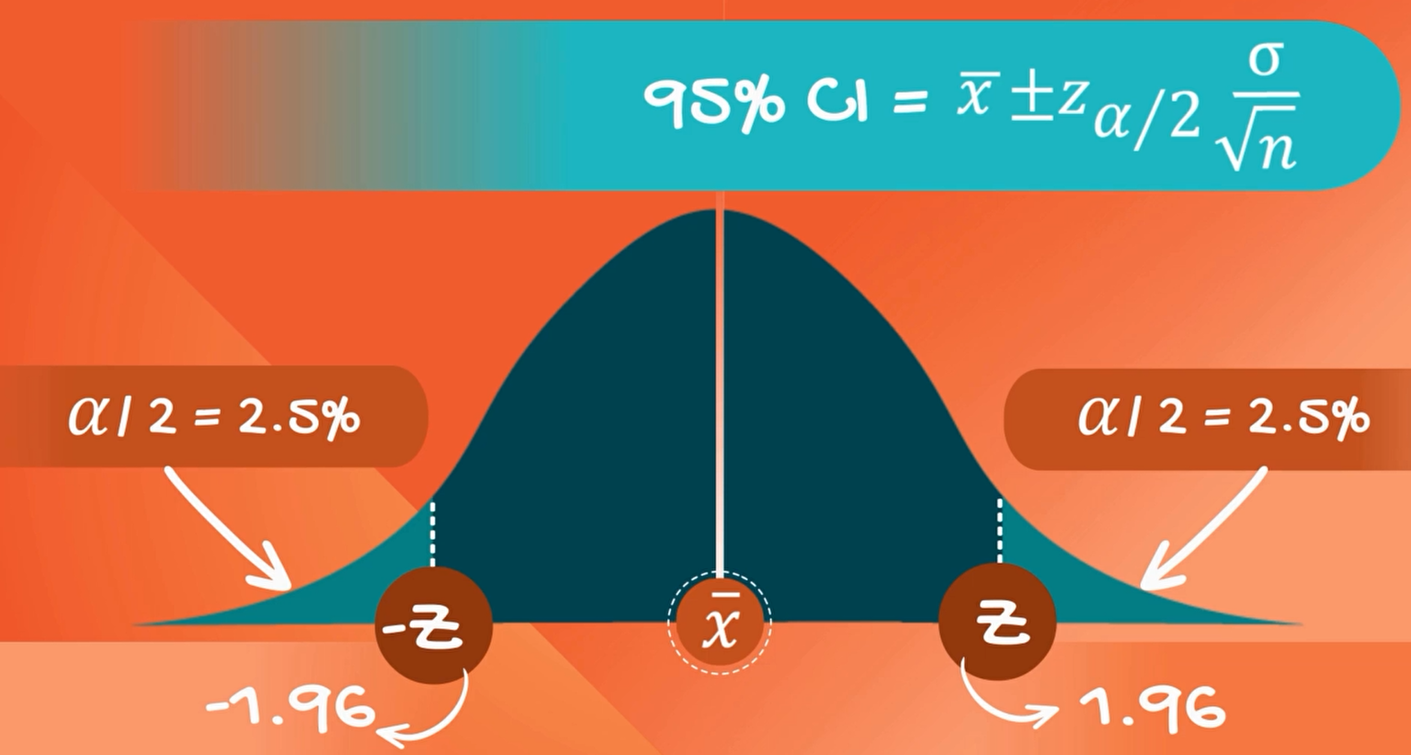

90% Confidence Interval

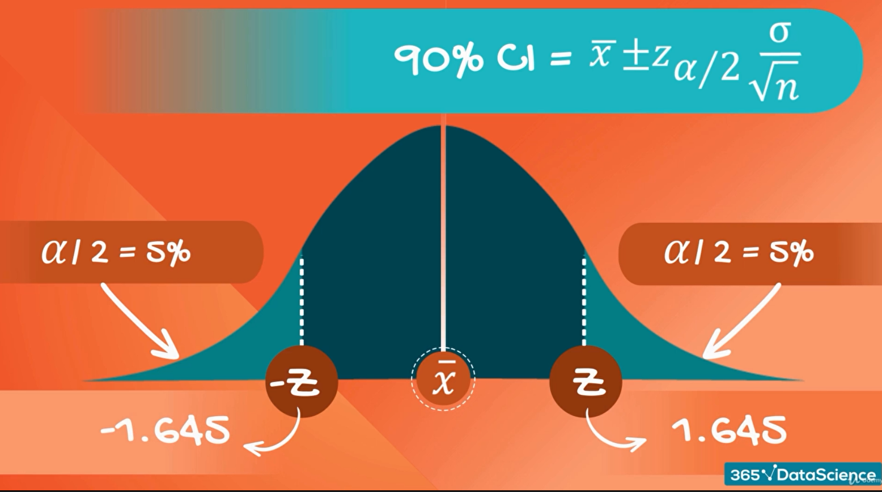

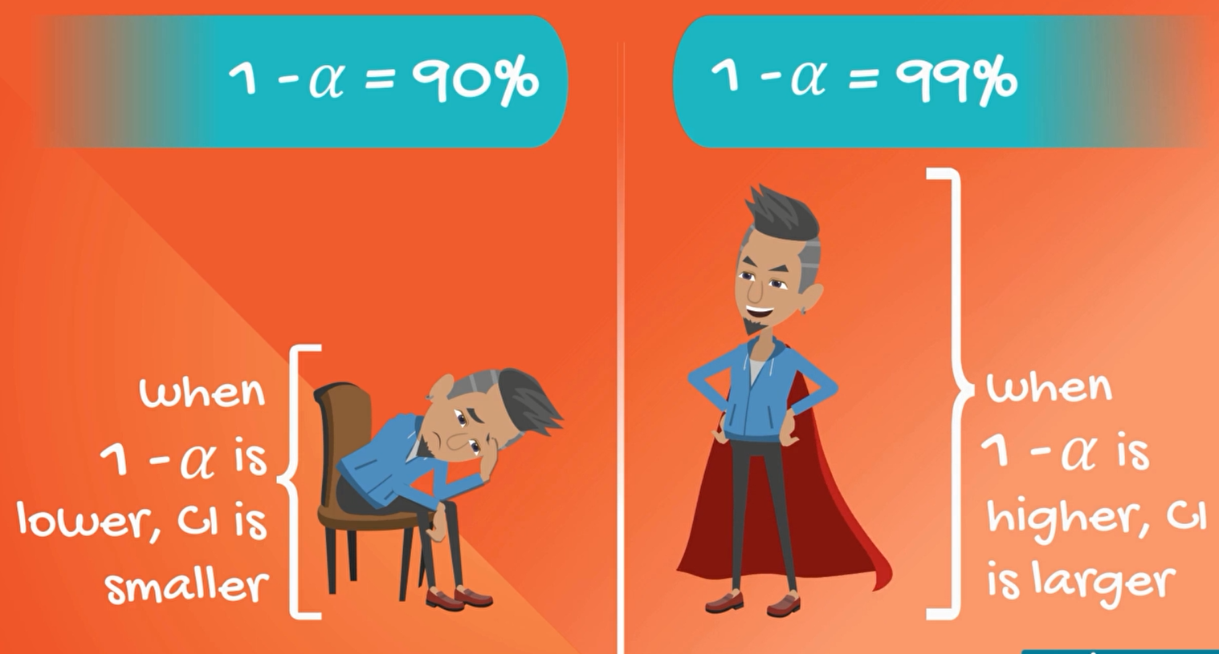

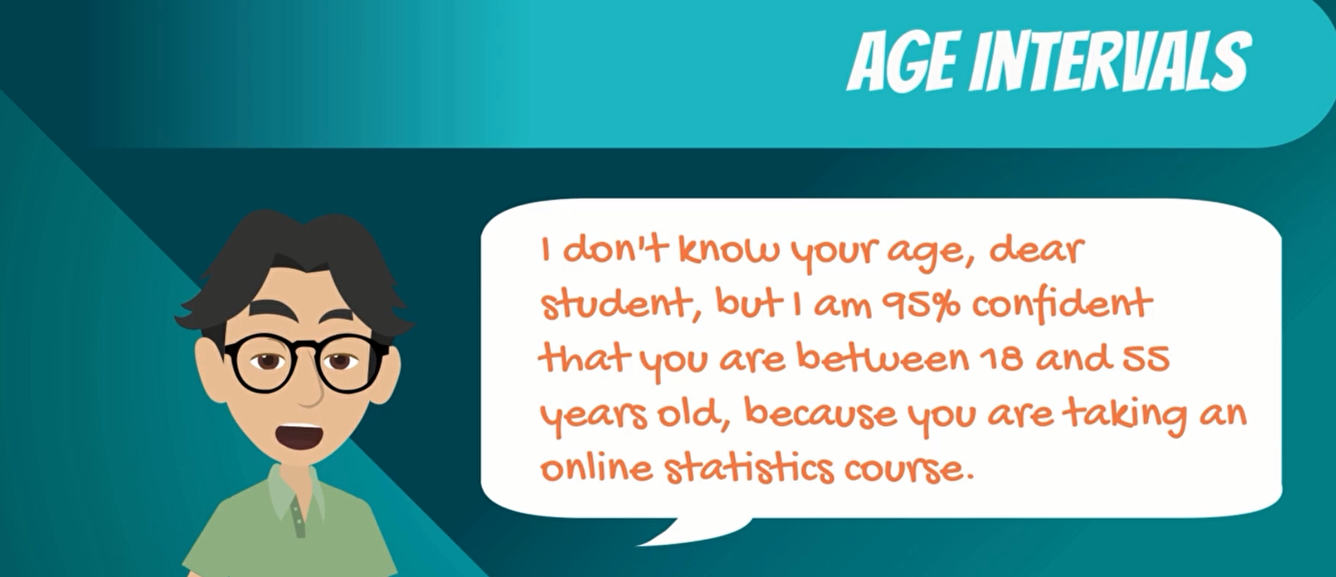

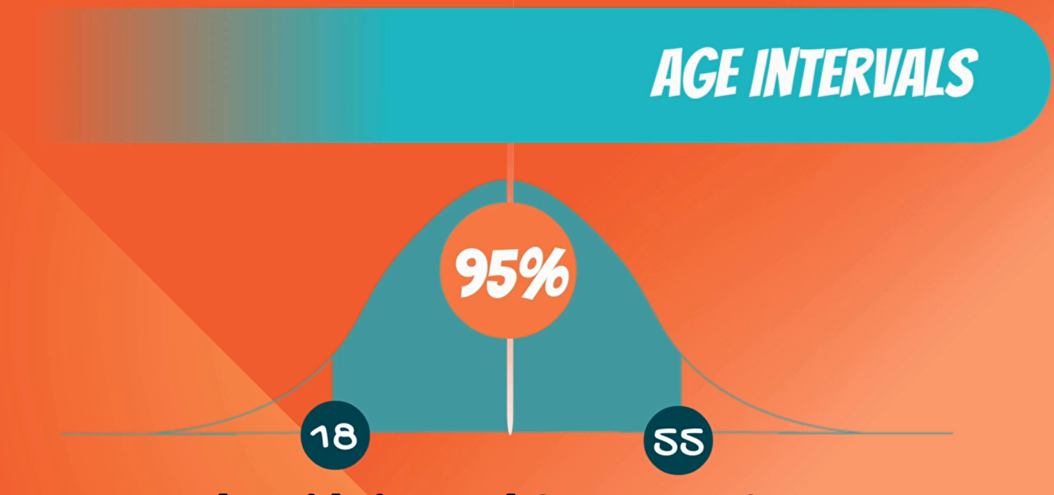

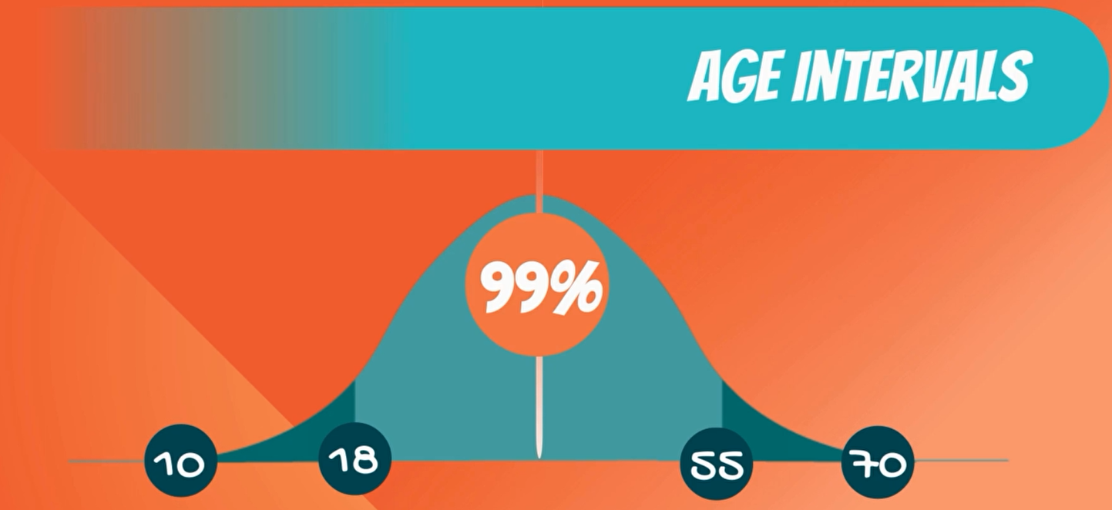

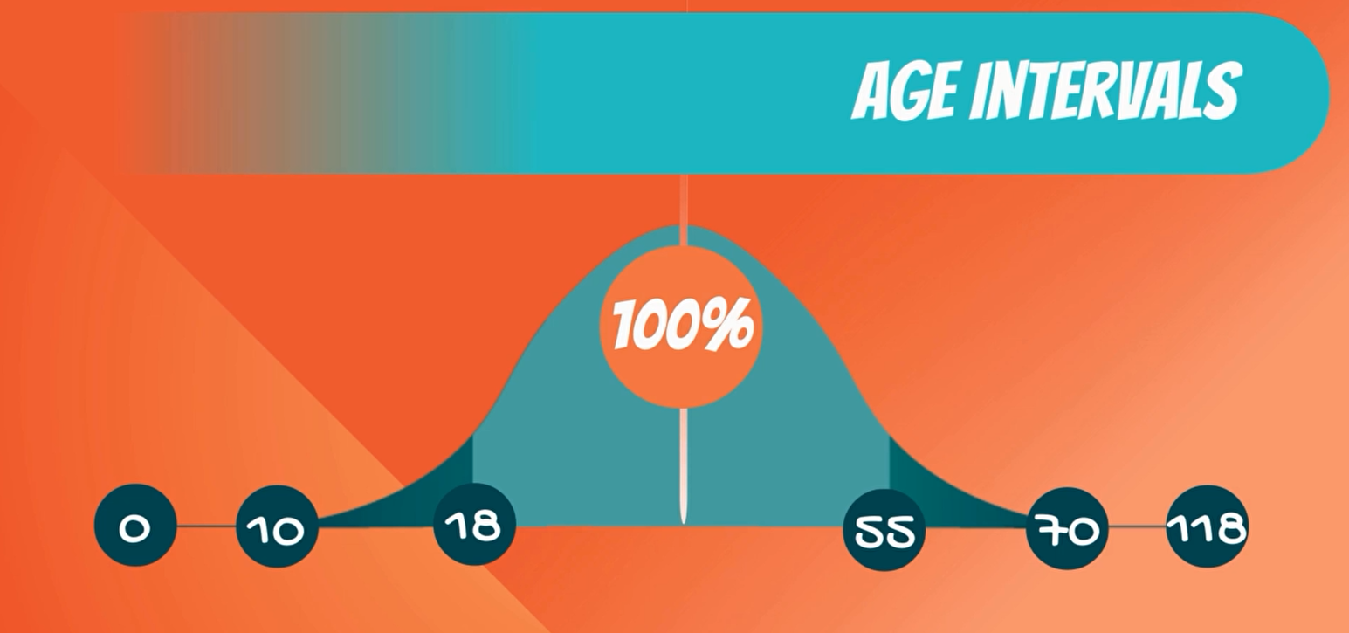

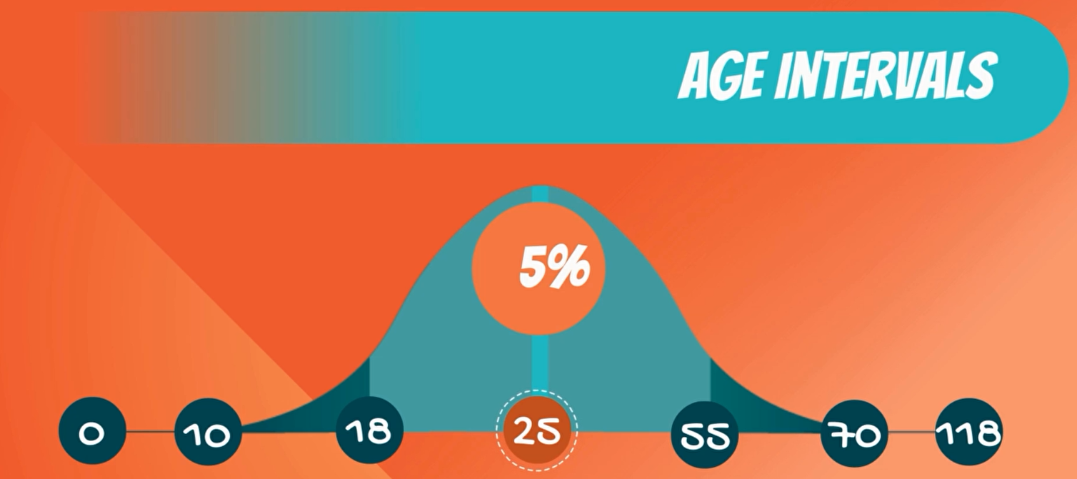

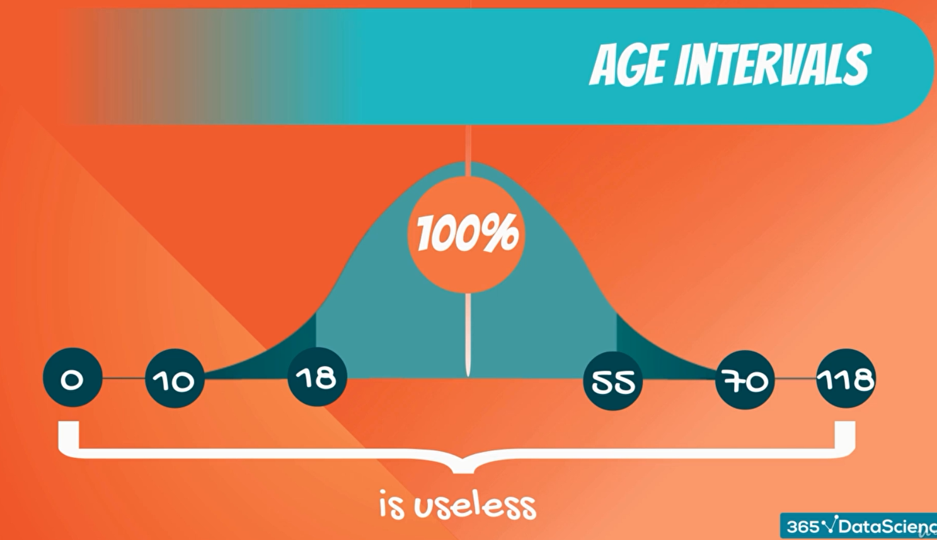

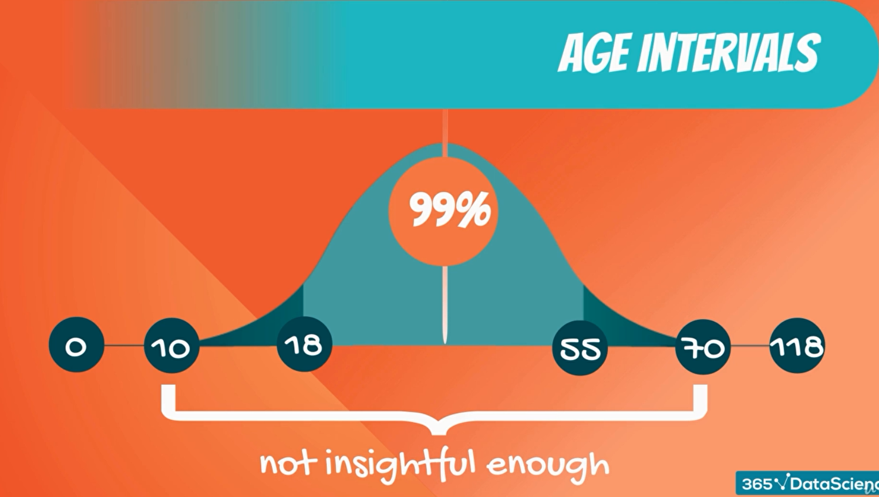

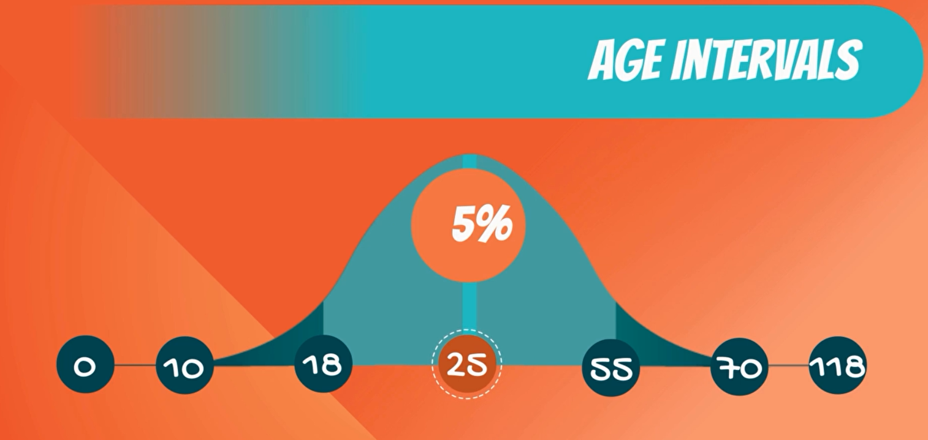

25 years old on the other hand is a pretty useful estimate as we have an exact number but the level of confidence of 5% is too small for us to make use of in any meaningful analysis.

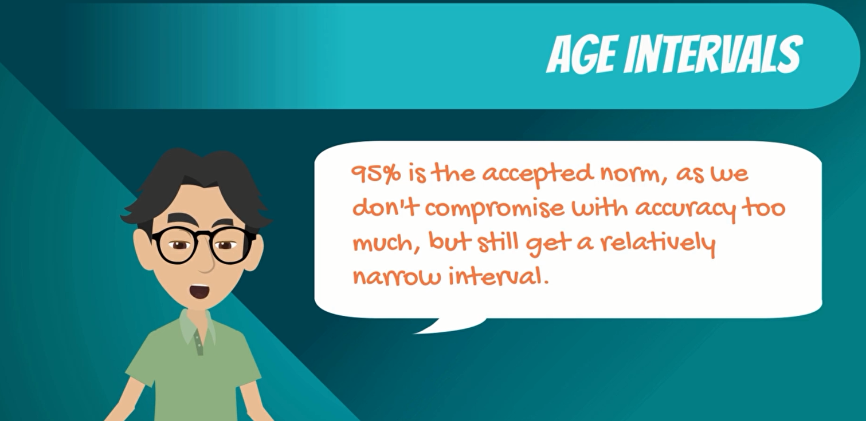

**6. Student's T Distribution**



It allowed inferences through small samples with an unknown population variance this setting can be applied big part of the statistical problems.

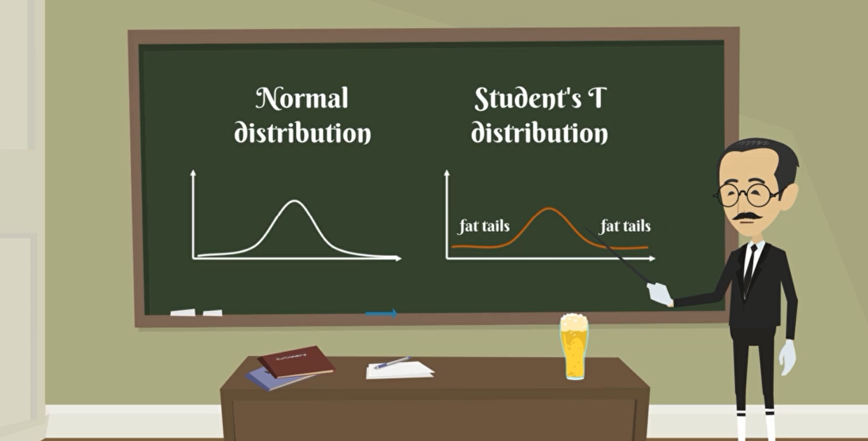

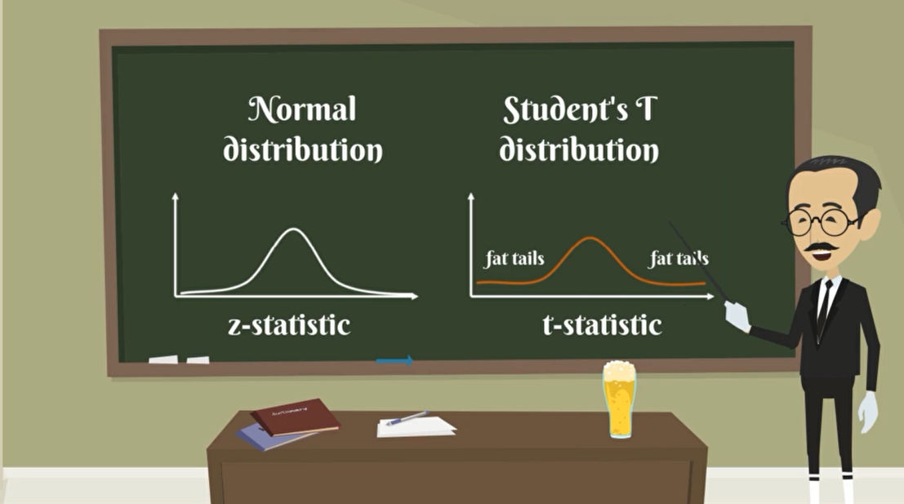

visually the student's t distribution looks much like a normal distribution but generally has fatter tails, fatter tails as you may remember allows for a higher Dispersion of variables and there is more uncertainty.

Z statistic is related to the standard normal distribution.

The t statistic is related to the student's t distribution.

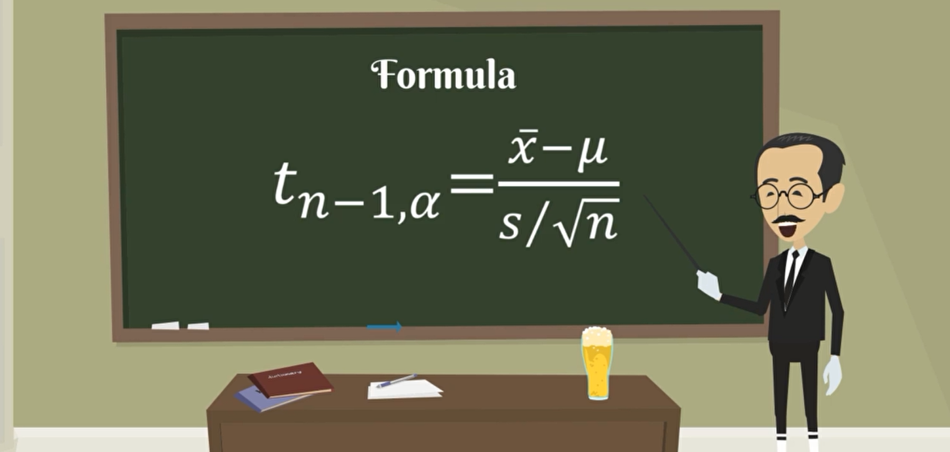

Degrees of freedom= tn-1 (t with n-1)

Sample mean = $\overline{x}$

Population mean= µ (mu)

Significant of alpha = α

Standard error= **σ/ $\sqrt{n}$** (σ/s standard deviation)

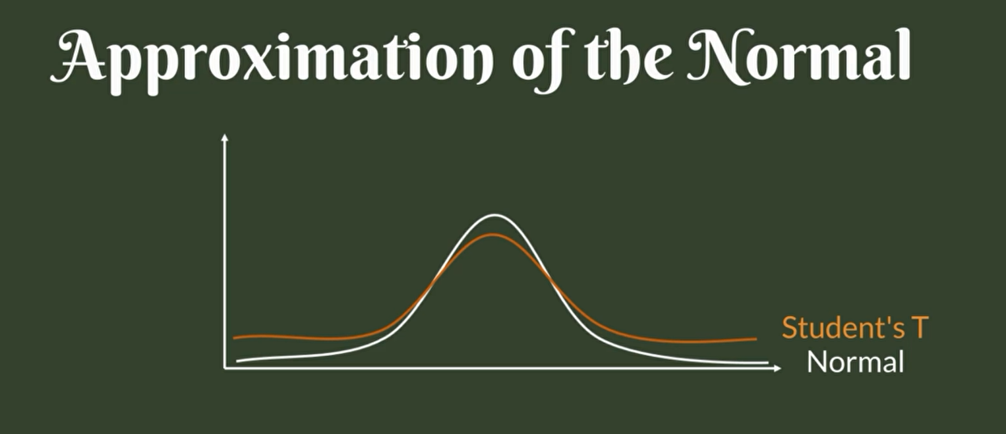

Tt is very similar to the Z, after all this is an approximation of the normal distribution.

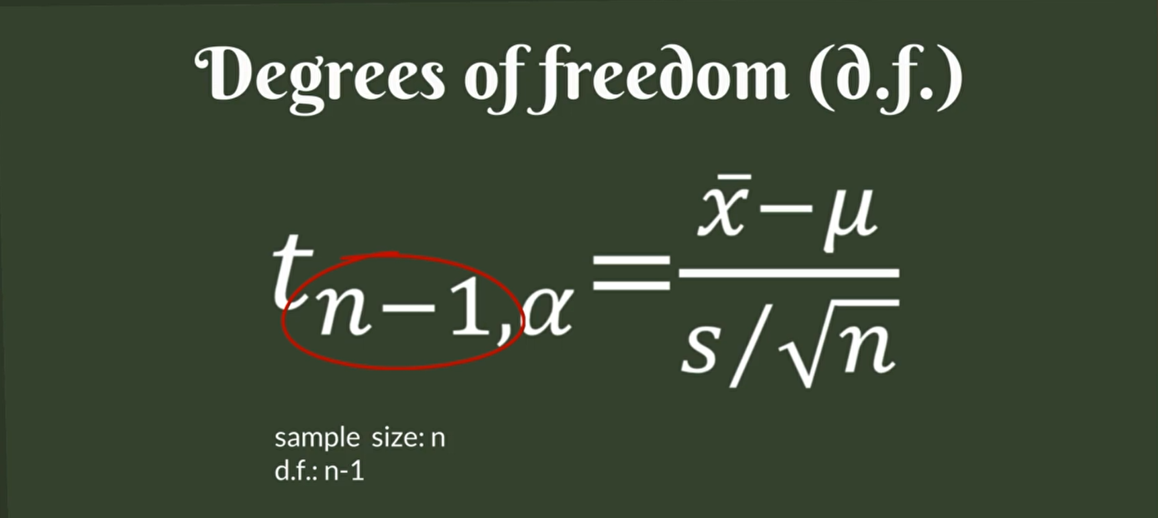

The last characteristic of a student's t statistic is that there are degrees of freedom, usually for a Sample of N, we have n -1 of degrees of freedom.

**8. Confidence Intervals; Population Variance Unknown; t-score**

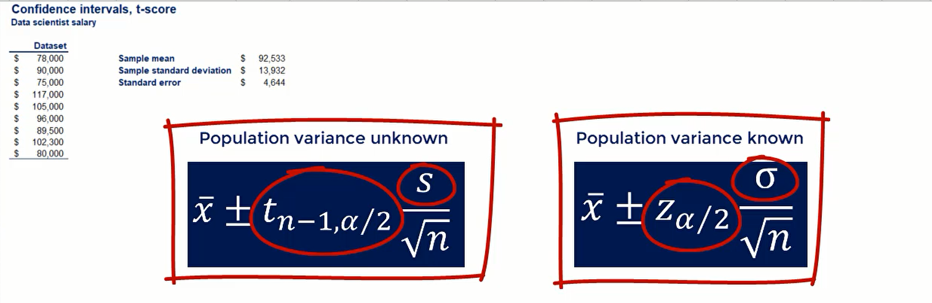

There are two key differences.

1. first instead of a z statistic we have a t statistic and
2. second instead of population standard deviation we have sample standard deviation.

otherwise, everything is the same. so, it should not be that difficult.

when population variance is unknown sample standard deviation goes with the t statistic.

when population variance is known population standard deviation goes with the z statistic.

**Confidence Interval**

in this example we are going to use a confidence interval of 95%, this means that Alpha is equal to 5%. therefore, half of Alpha would be 2.5%.

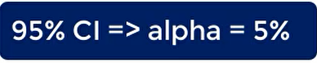

t statistic

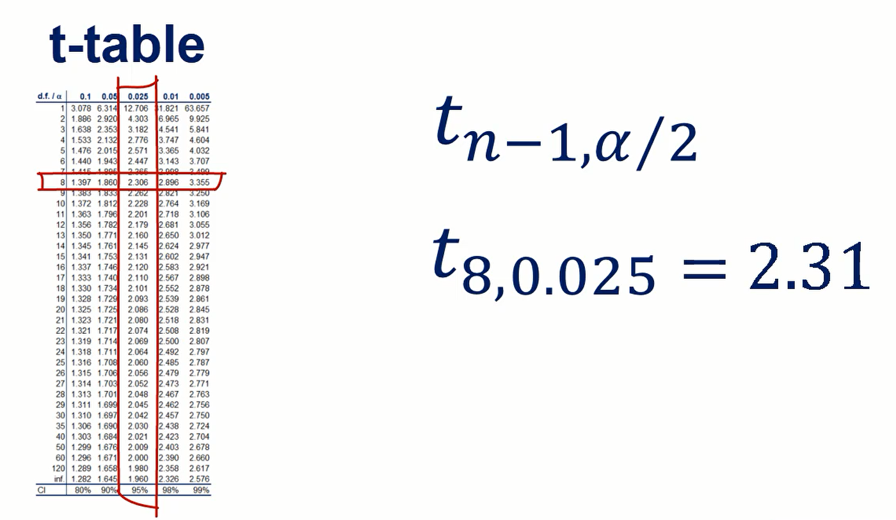

instead of finding Alpha we can just check the 95% confidence interval and get the same result.

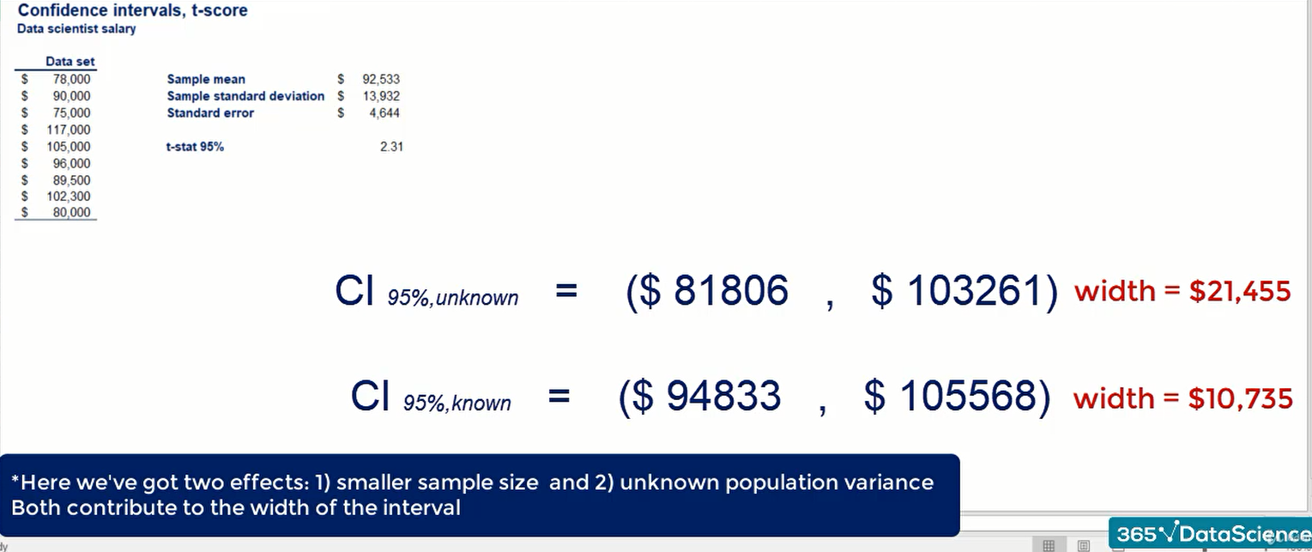

**Confidence interval, t score**

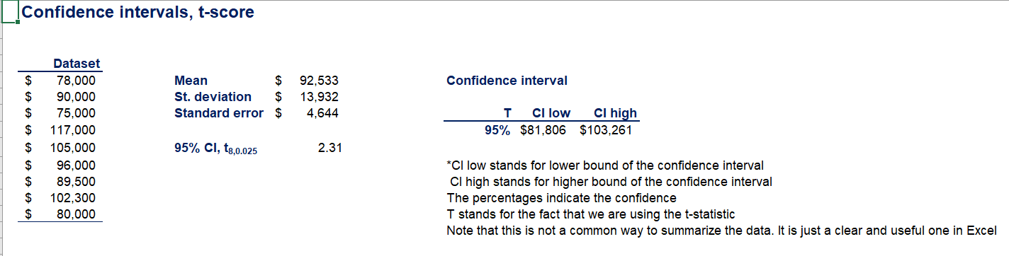

**t - table**

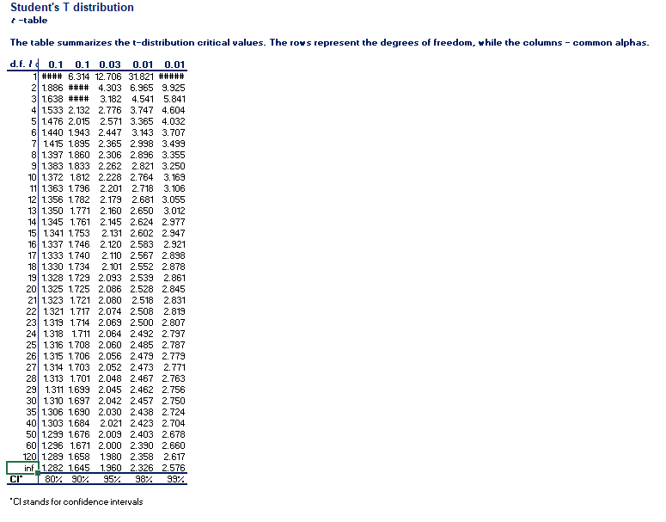

when we know the population variance, we get a narrow confidence interval.

when we do not know the population variance there is a higher uncertainty that is reflected by wider boundaries for our Interval.

**We learned today**

when we do not know the population variance, we can still make predictions but there would be less accurate

**10. Margin of Error**



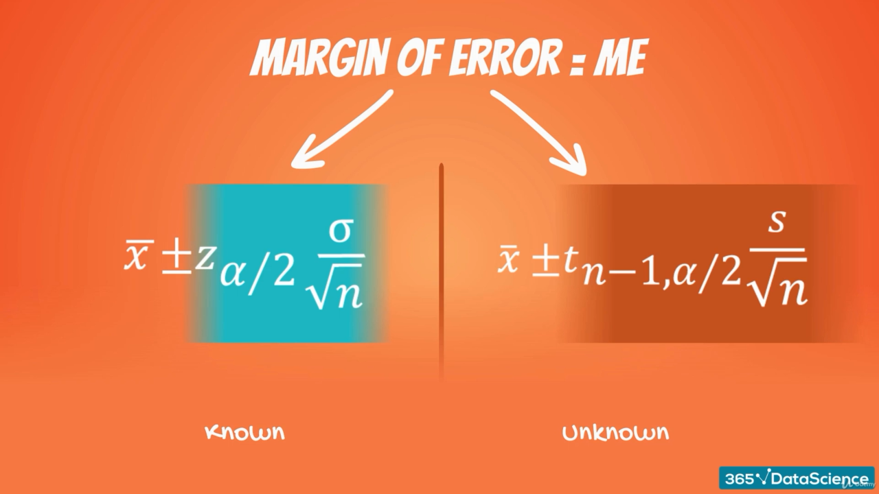

the margin of Error is equal to this expression and in the case of population variance unknown

the margin of Error is equal to this expression and in the case of population variance known

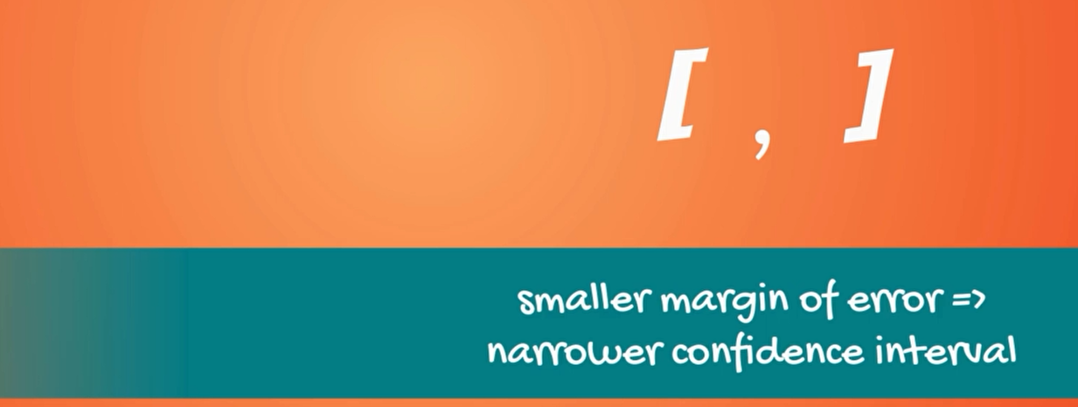

getting a smaller margin of error means that the confidence interval would be narrower as we want a better prediction.

**Control the margin of error**

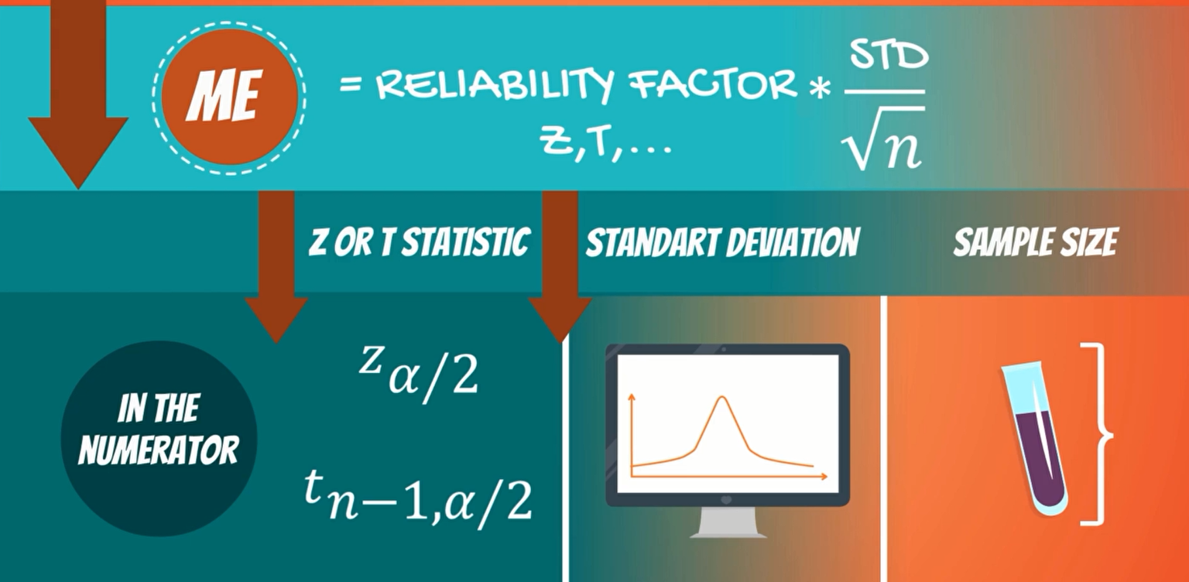

There is a statistic, a standard deviation and the sample size, statistic and the standard deviation are in the numerator. So, smaller statistics and smaller standard deviations will reduce the margin of error.

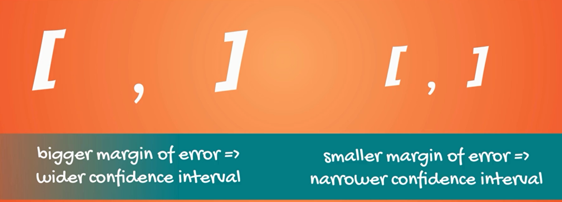

How do we do that a higher level of competence increases the statistics, a higher statistic means a higher margin of error.

This leads to a wider confidence interval.

Example



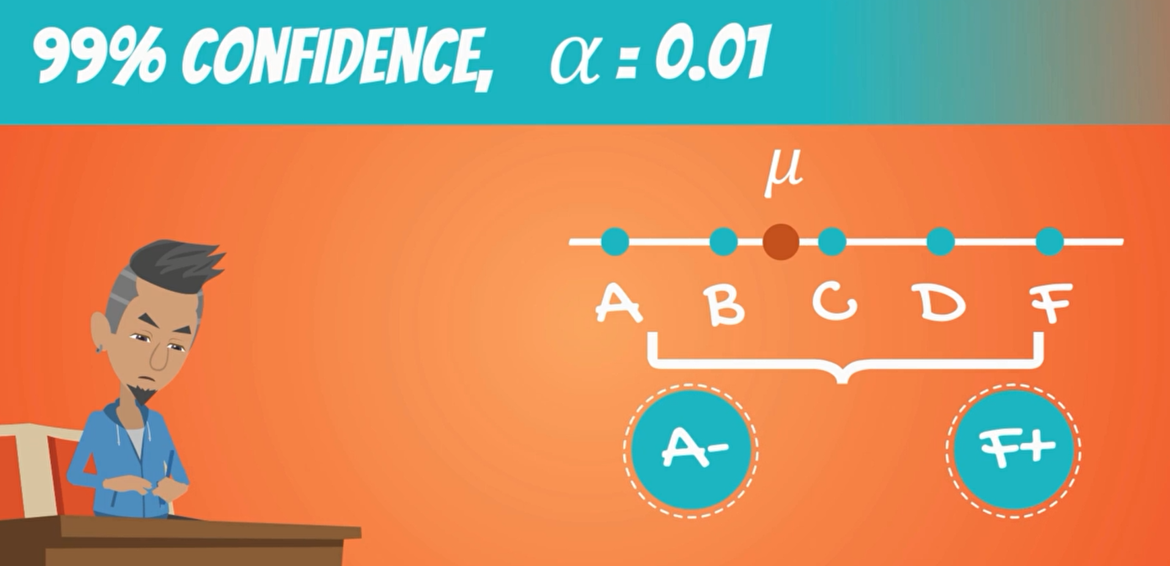

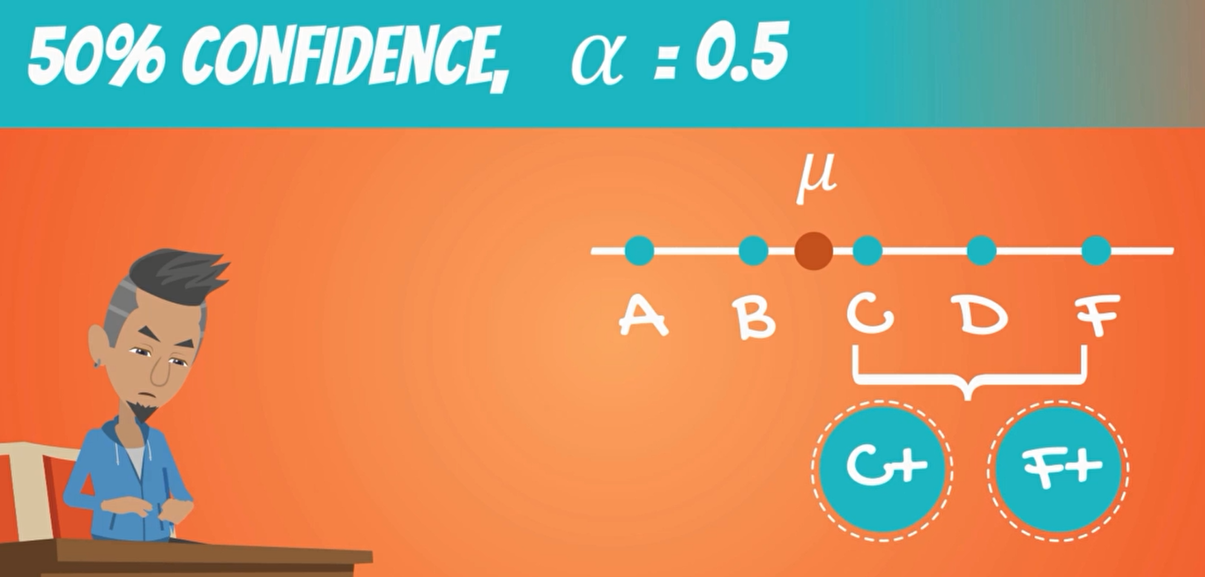

Lower confidence level result in a narrower interval.

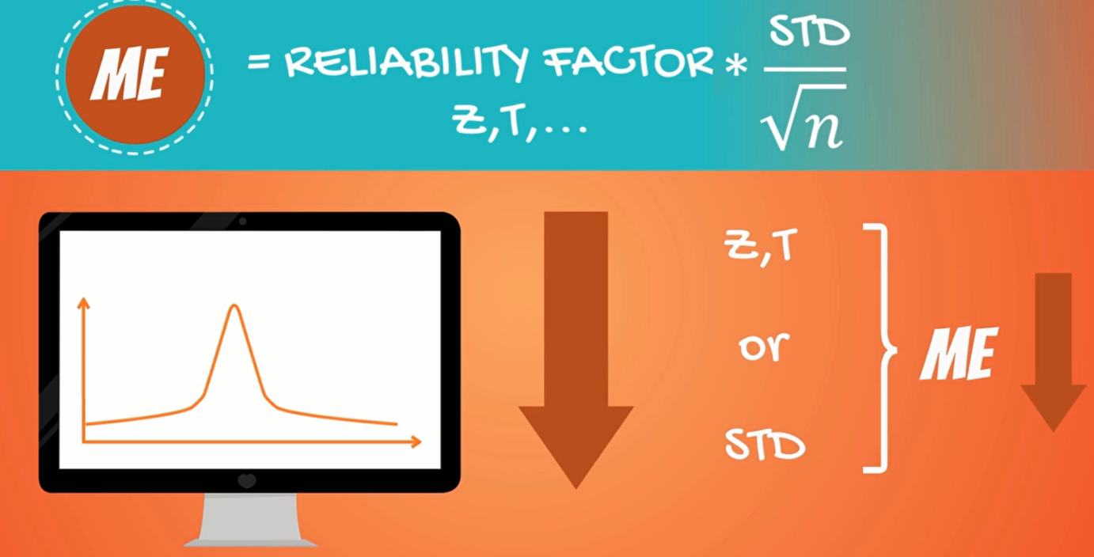

a lower standard deviation means that the data set is more concentrated around the mean

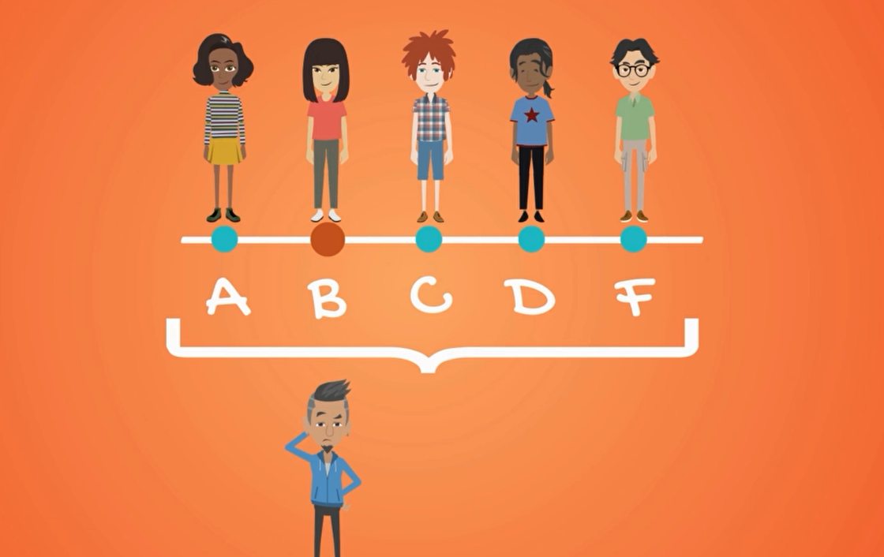

for instance, the mean grade in your class is B and you know that there are people with in A's B's C's D and a few F's. how likely is it that you got a B now?

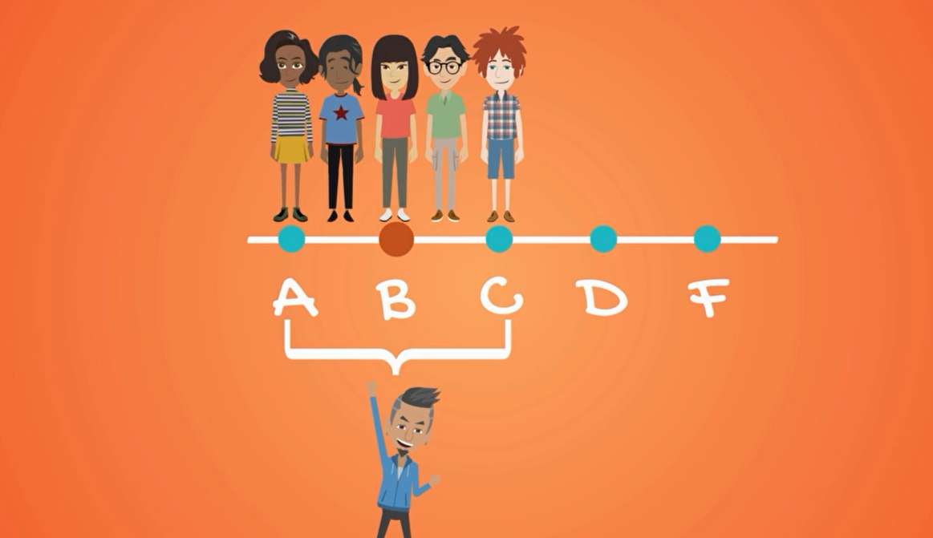

compare this to a situation when the teacher said the mean of the class is around B and the lowest grade is C.

in this case you are much more likely to get a B right, in the first case the grades are dispersed while in the second they are concentrated.

lastly the higher sample size will decrease the margin of error.

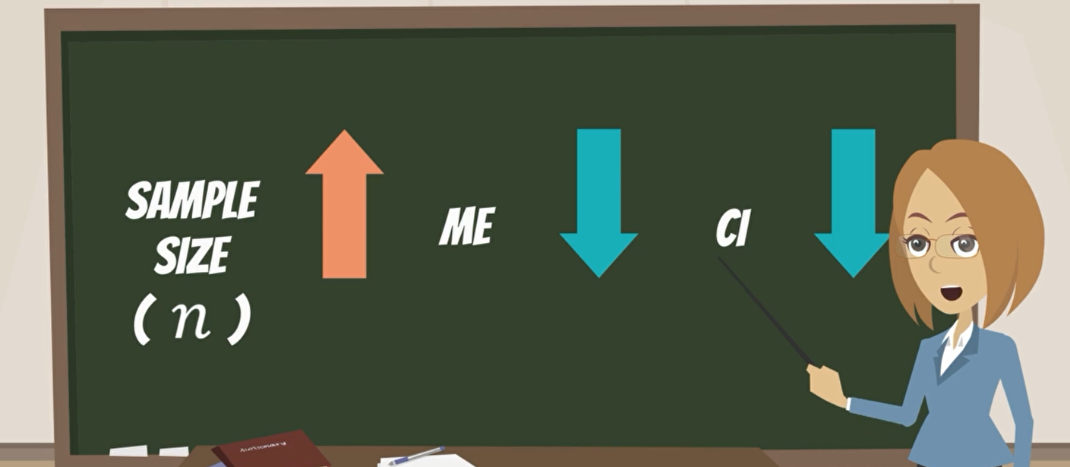

Sample N= 30 students



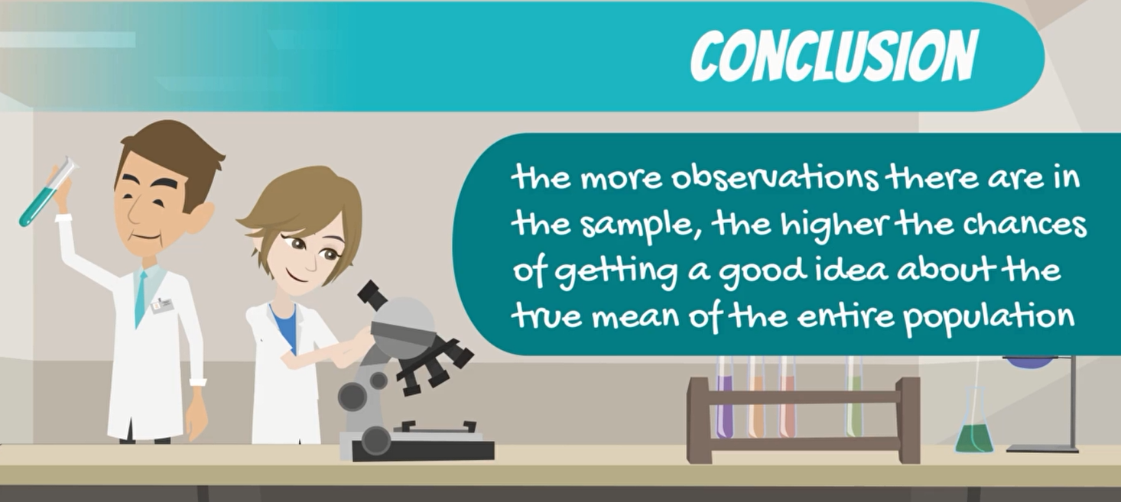

**12. Confidence intervals. Two means. Dependent samples.**

We will explore confidence interval looking into two population.

In some cases, the samples that we have taken from that populations will be dependent on each other and in others they will be independent, dependent samples are easier.

first when we are researching the same subject. examples are **weight loss** and **blood samples.**

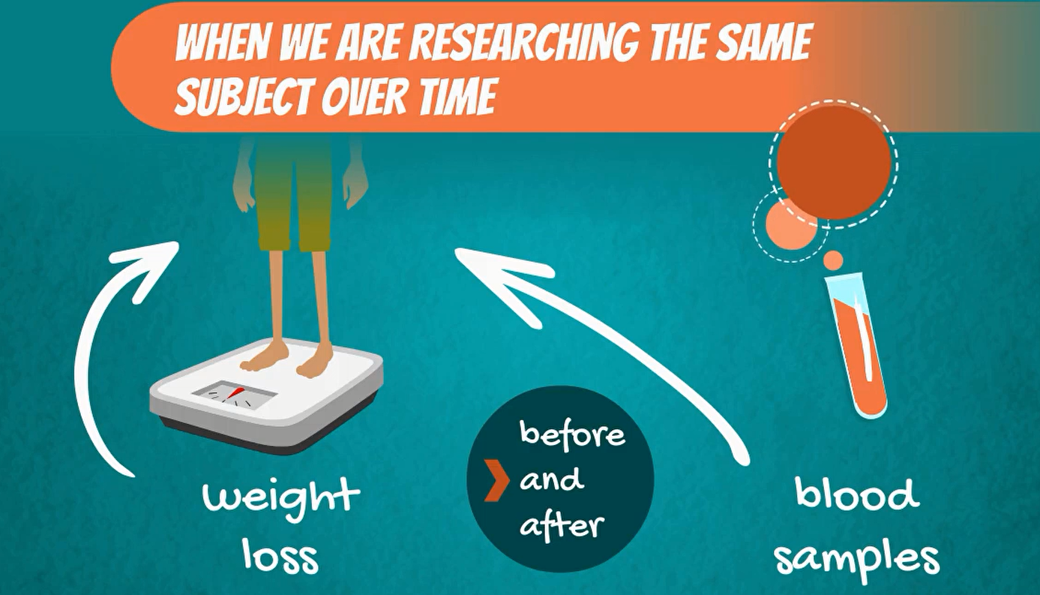

essentially, we are looking at the same person before and after. these two examples will be explored and detailed in these lessons.



Another case in which we have dependent samples is when investigating couples or families. for instance, habits of husbands and wives.

They are obviously dependent on each other at the time, these people spend together at home often coincides watching TV, eating dinner, often sharing the same household income.

**Types of samples**

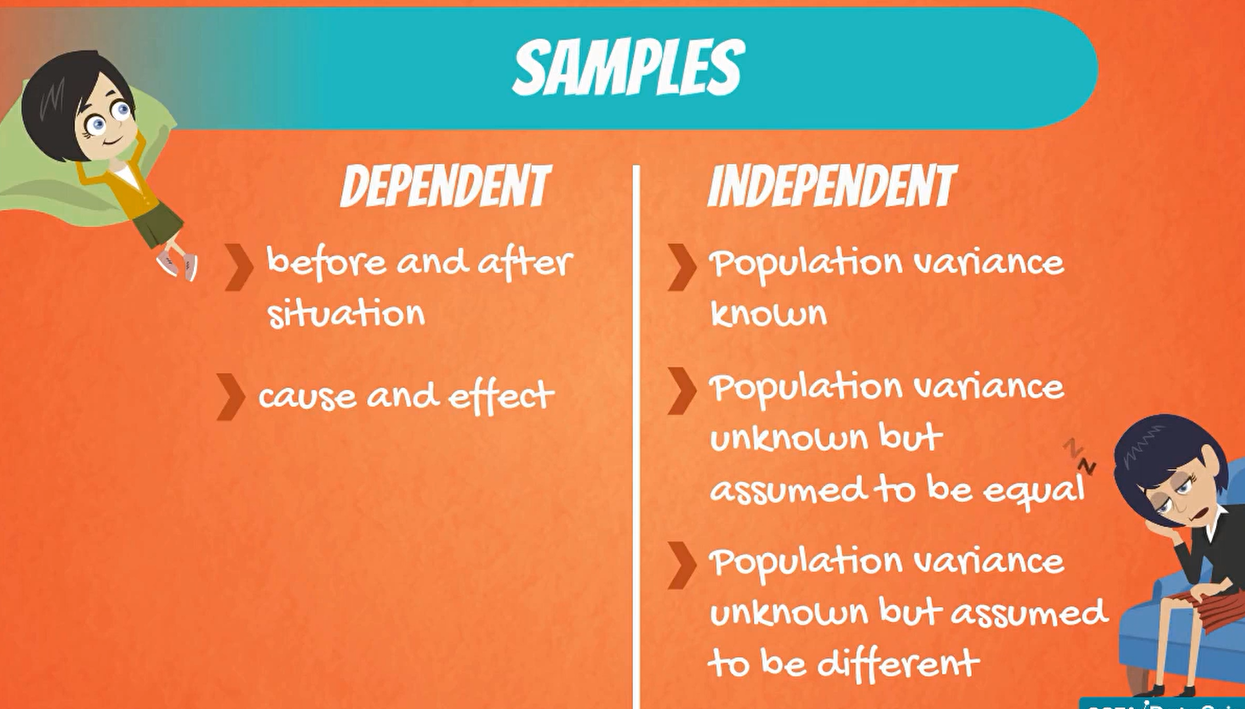

**Dependent Samples**

This statistical test is often used when developing medicine.

let's say you have developed a pill that increase the concentration of magnesium and blood.



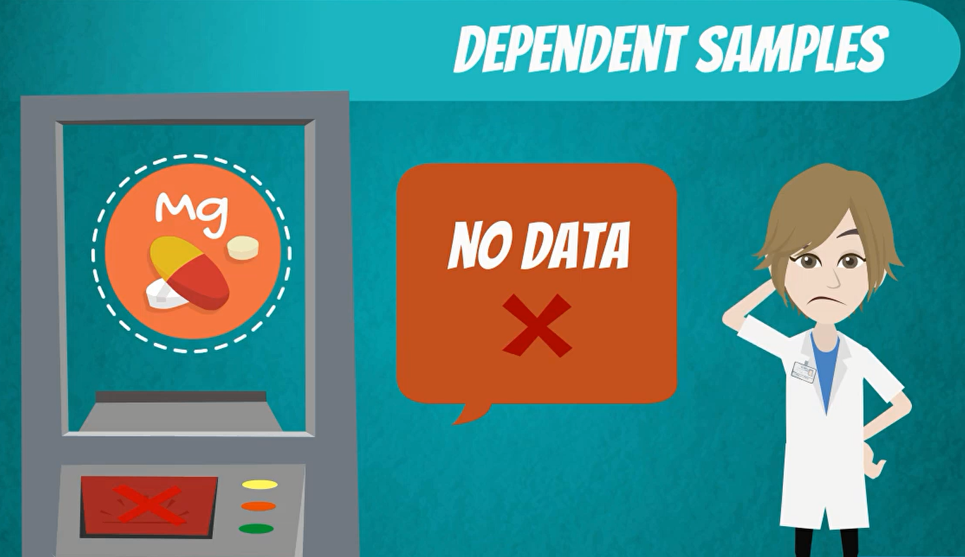

It is very promising but there is no data to support your claim.

after testing the drug in the laboratory, it is time to see its actual effect on people.

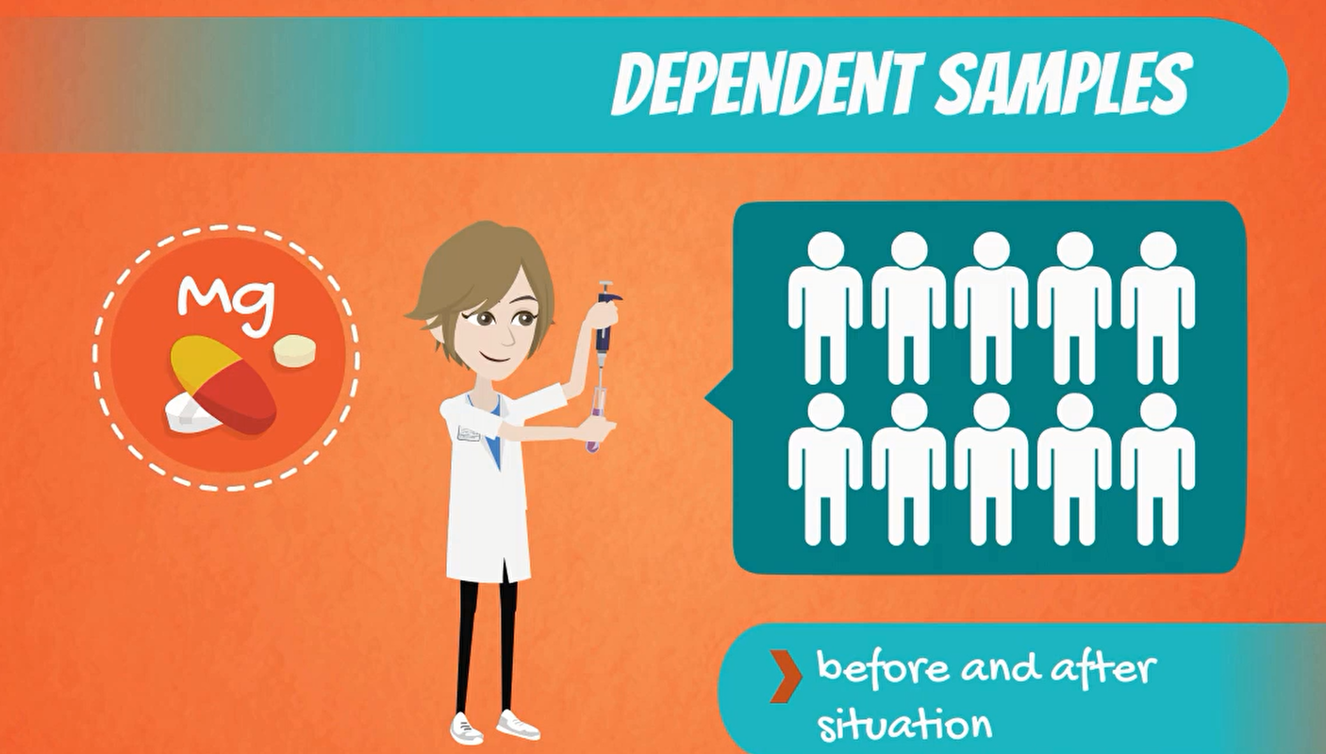

what you would typically do is take a sample of 10 people and tests or magnesium level before and after taking the pill.

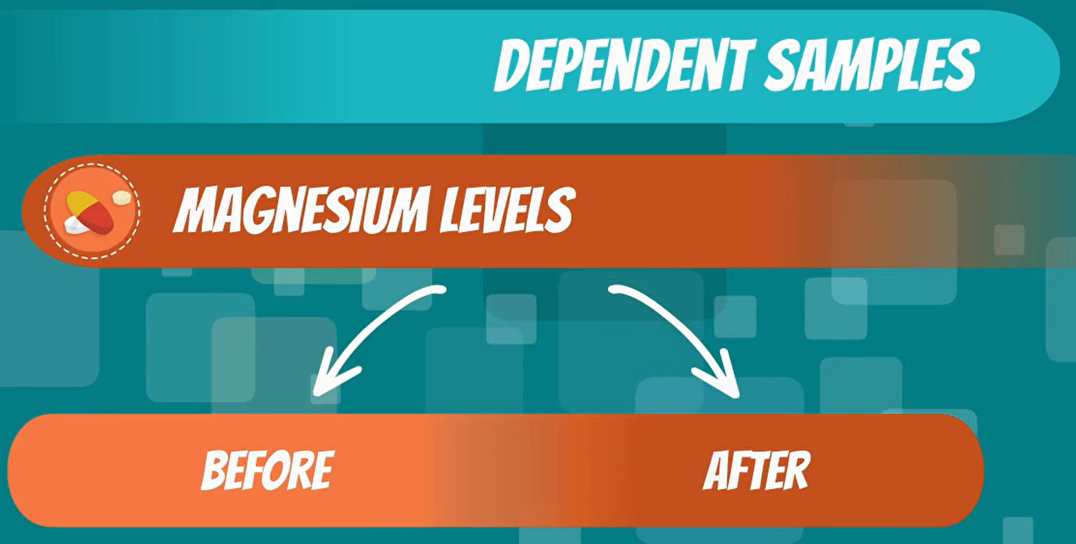

The two dependent samples are the magnesium levels before and the magnesium levels after. it is clear that it is the same people, we are testing because the samples are dependent.

**Note**

an important note is that the populations are normally distributed Actually when telling with biology.

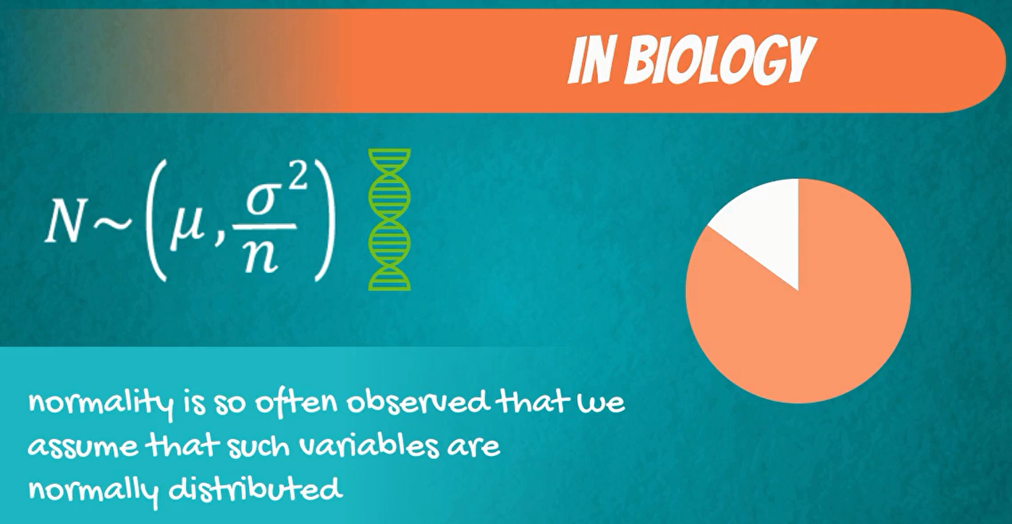

whenever you take a blood test the magnesium levels are stated in mg per deciliter and a healthy person would usually have somewhere between 1.7 and 2.2 mg of magnesium mg per deciliter.

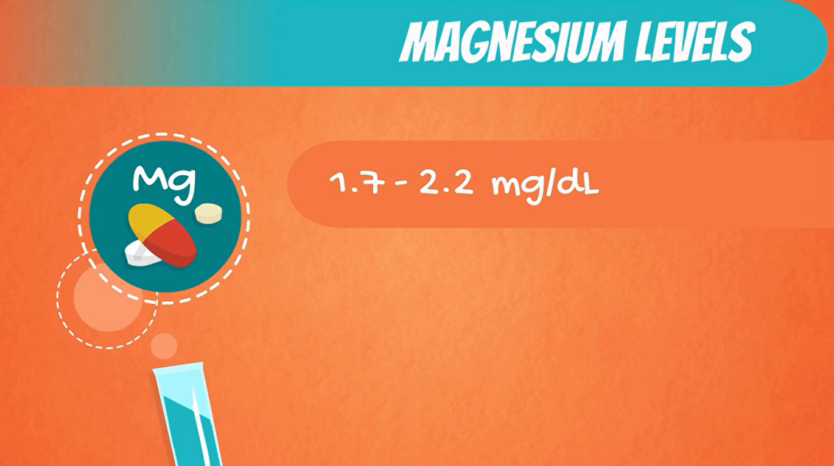

Confidence interval for difference of two means, dependent samples

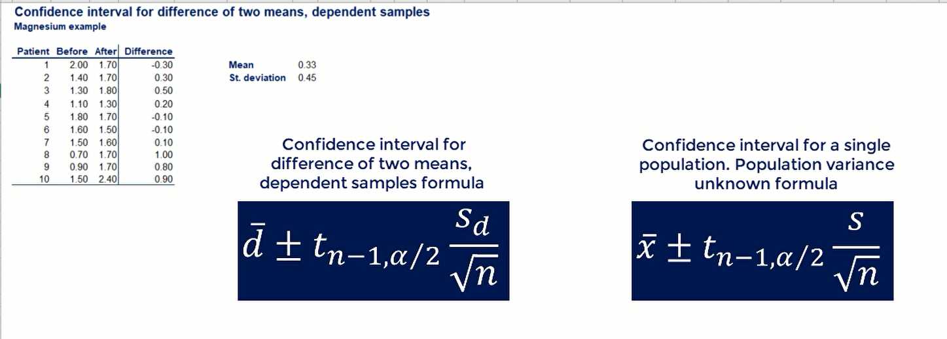

  

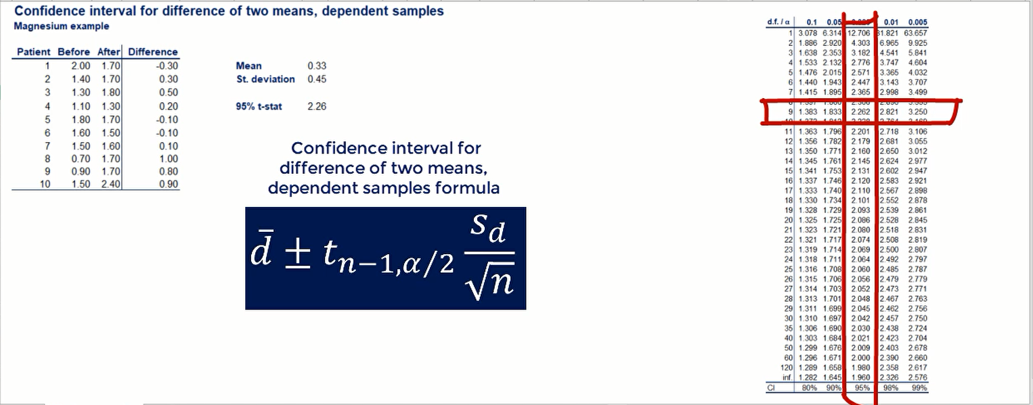

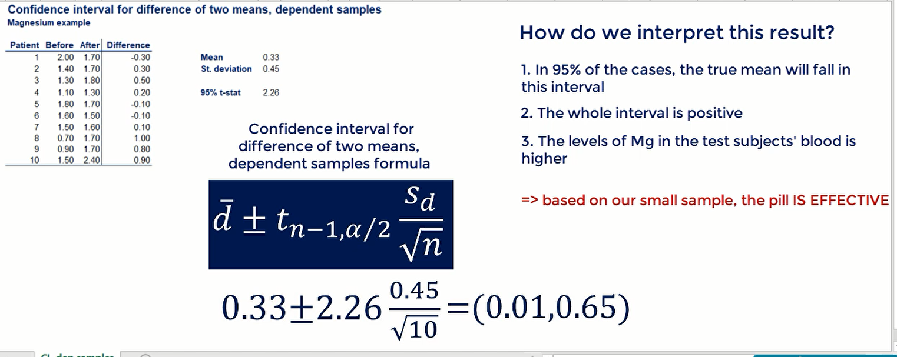 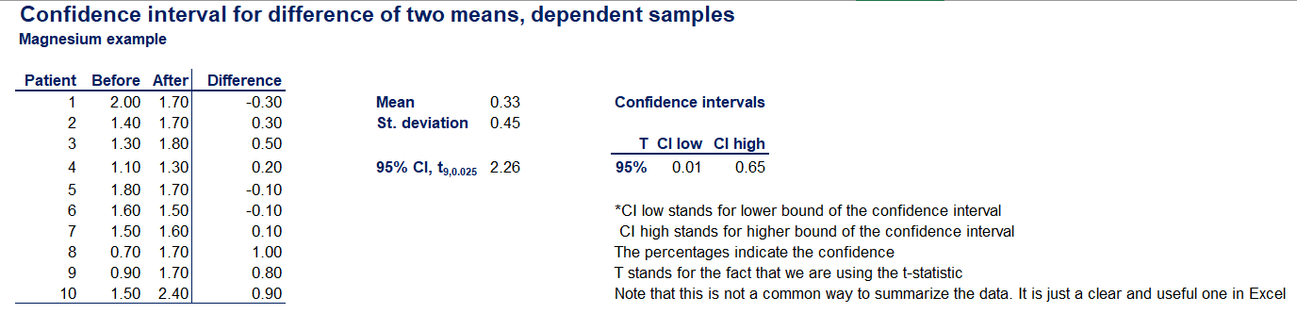

this shows that the true meaning of the difference is definitely positive. therefore with 95% certainty we can say that the levels of magnesium is the test subject blood is higher.

the purpose of this test was to determine whether the drug is effective based on our small sample.

this shows you some of the practical applications of inference

**14. Confidence intervals. Two means. Independent samples (Part 1)**

**Known population variances**

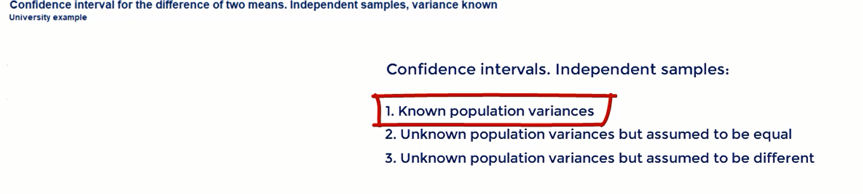

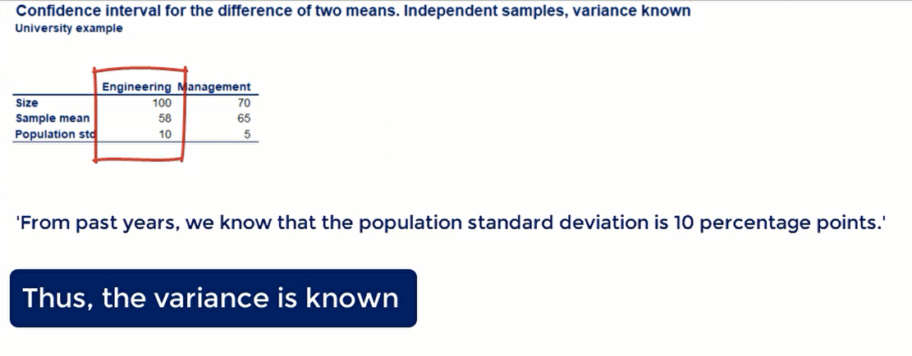

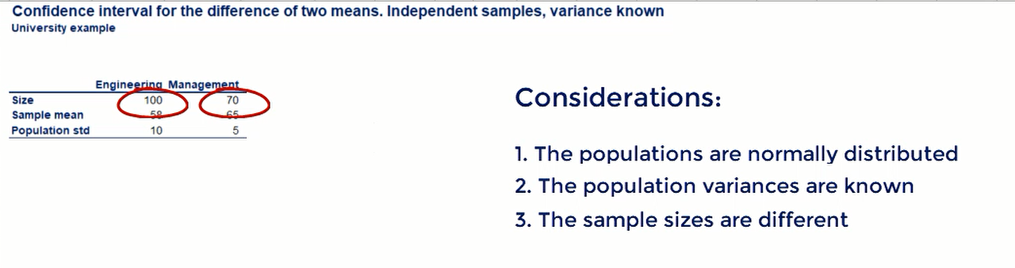

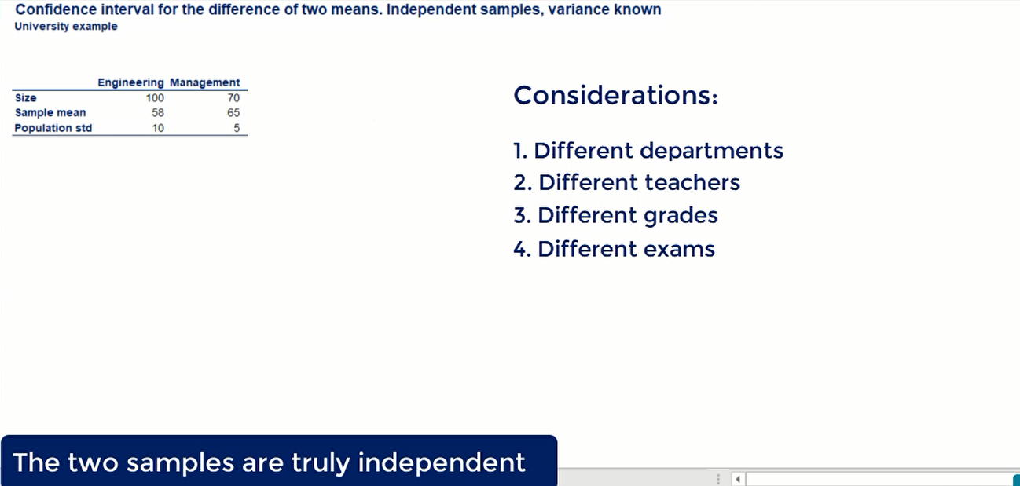

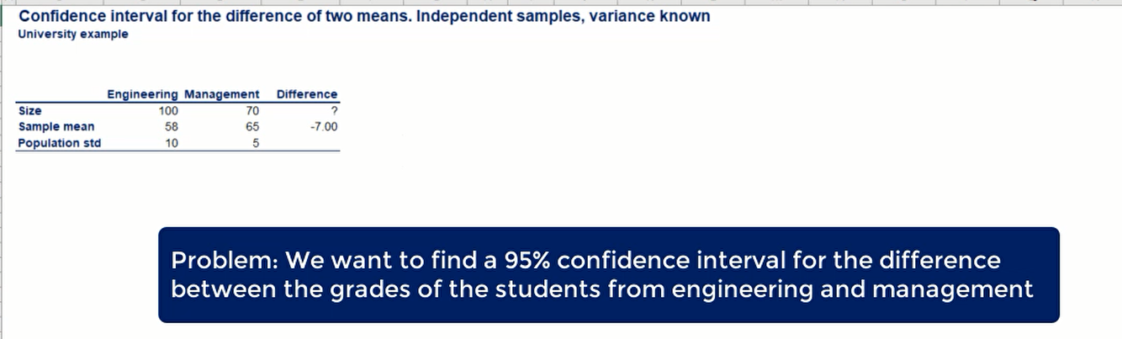

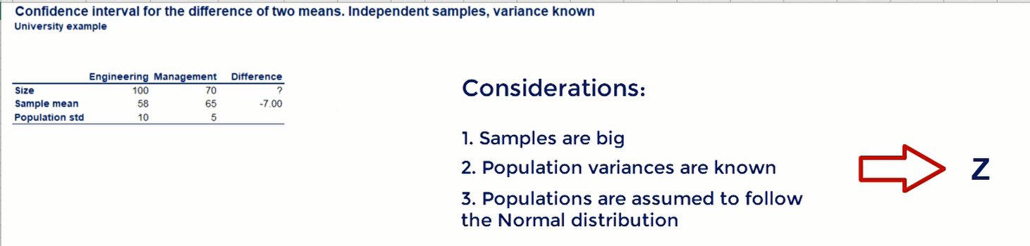

all this information points as to the z statistics instead of the t statistics

the variance of the difference between the two means

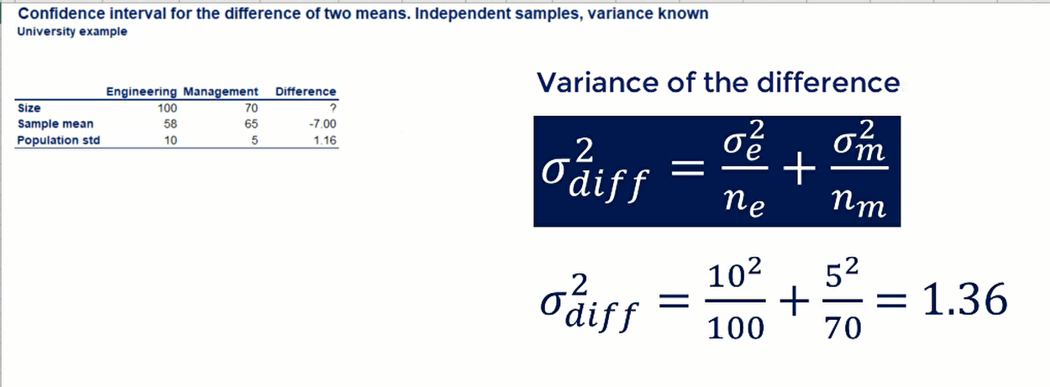

* The variance of the grades received by engineering students = **σe2**
* Sample size of the engineering students = ne
* The variance of the grades received by engineering students = **σm2**
* Sample size of the engineering students = nm

**Confidence intervals**

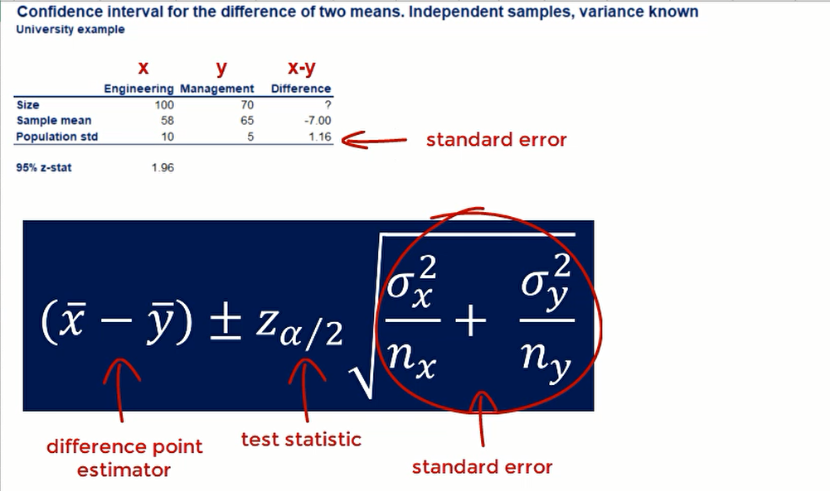

**interpretation**

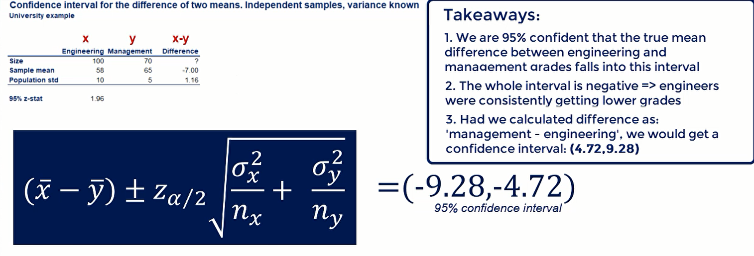

note that this time the whole interval is negative because we are calculating engineering grade minus management grade, as the engineers why were constantly getting lower grades. So, the difference is negative.

**16. Confidence intervals. Two means. Independent samples (Part 2)**

***population variances Unknown but assumed to equal.***





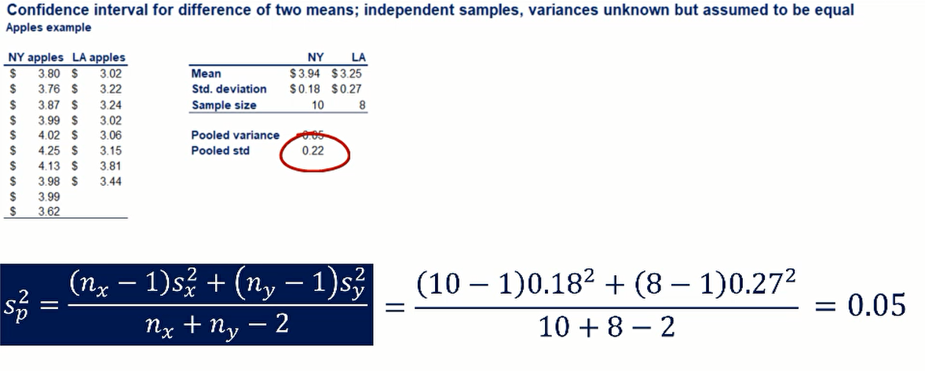 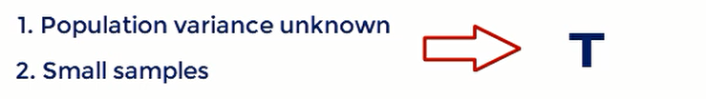

Pooled Variance Formula

**Statistic**

we assume that the population variances are equal

so, we have to estimate them, the unbiased estimate or in this case is called the **pooled sample variance**

* Sample Standard Deviation of NL apples = **sX2**
* Sample size of the NL apples = sX
* Sample Standard Deviation of LA apples = **sY2**
* Sample size of the LA apples = SY

Confidence Interval for known variance

Confidence Interval for unknown variance

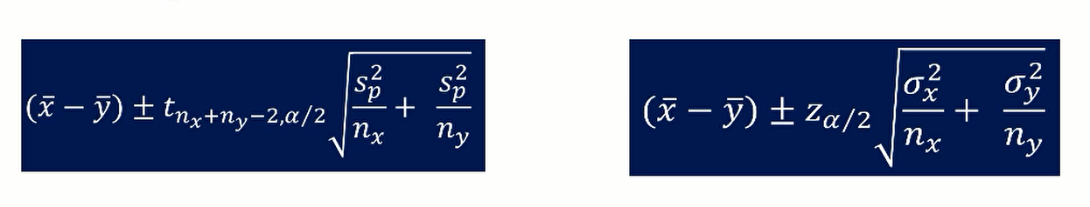

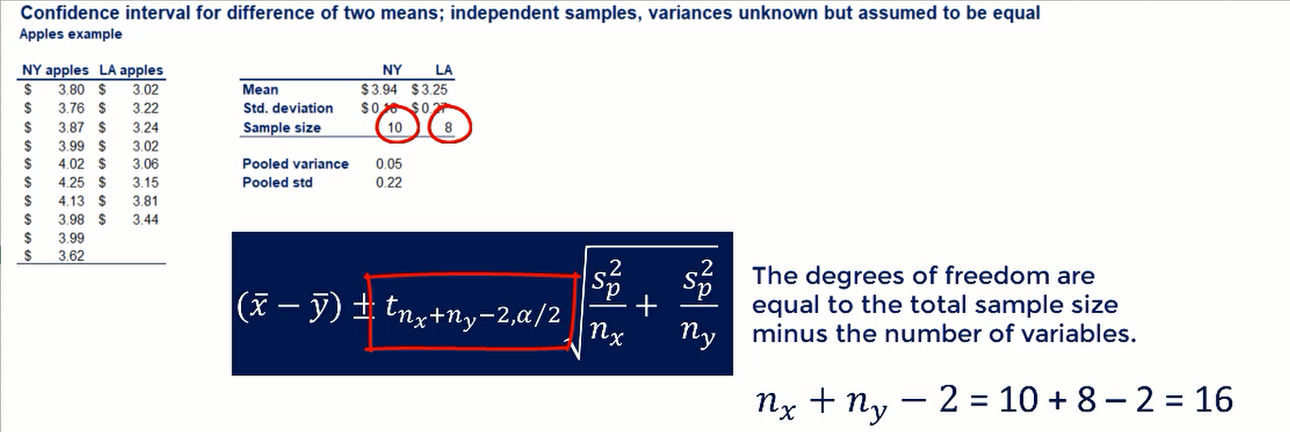

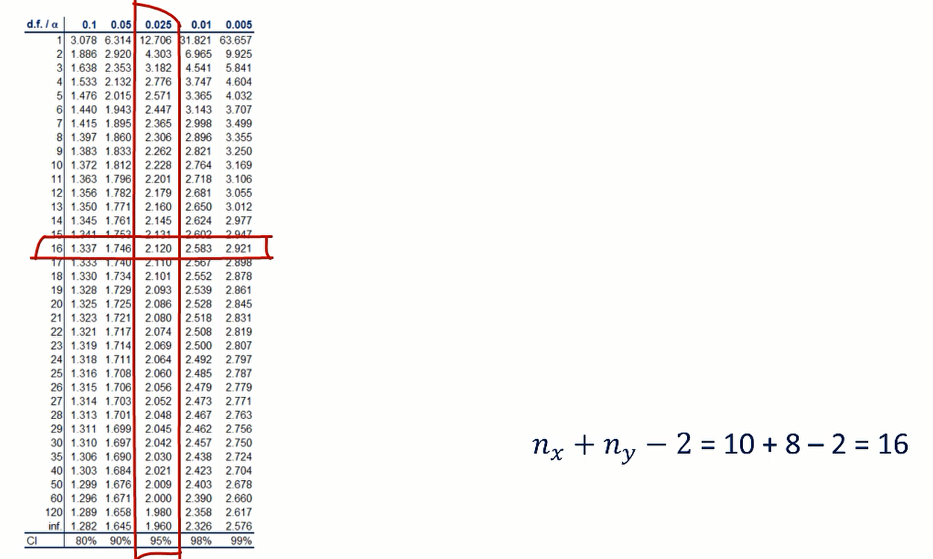

Confidence Interval Calculation

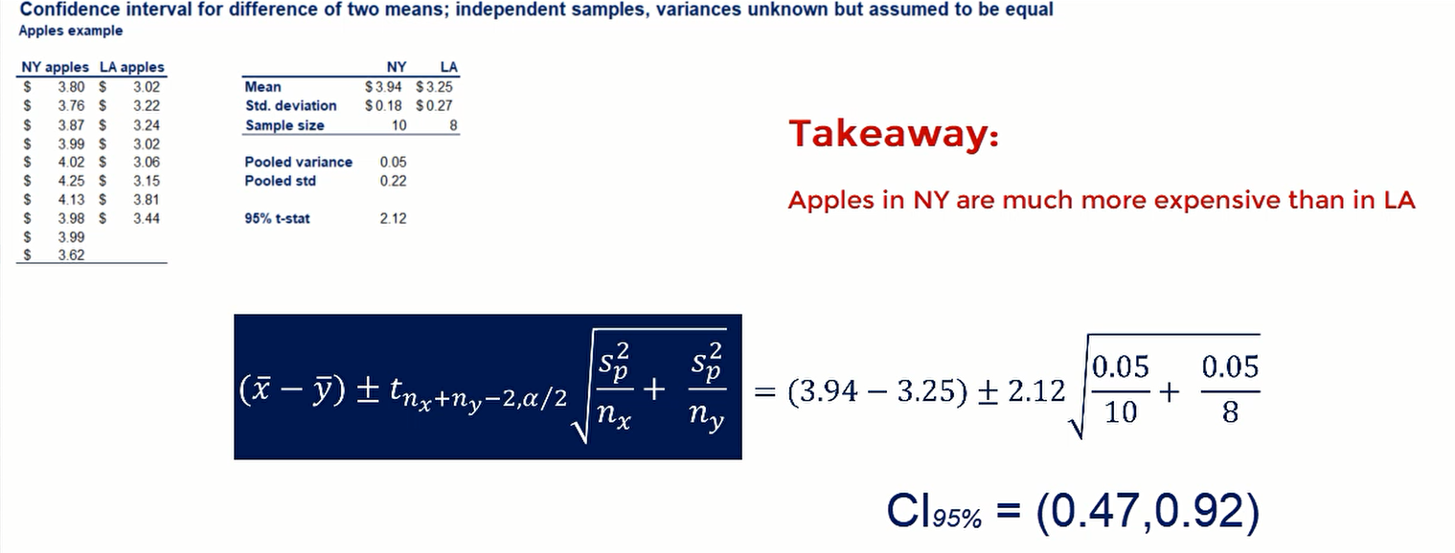

**18. Confidence intervals. Two means. Independent samples (Part 3)**

***population variances Unknown but assumed to different.***



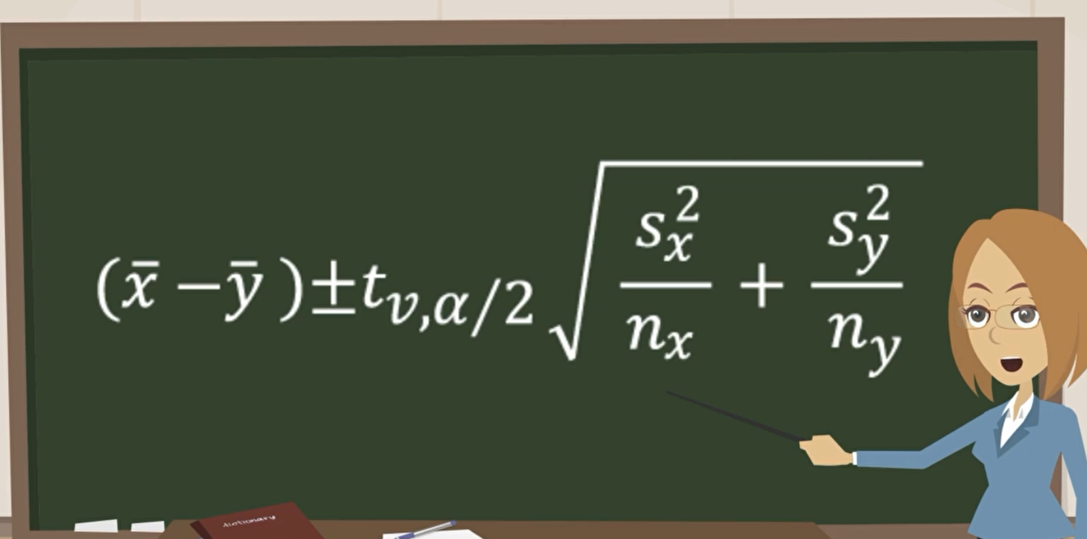

we have the difference of the means of the two samples the variance or the sample variance of each of the two variables and here are the respective sample sizes.

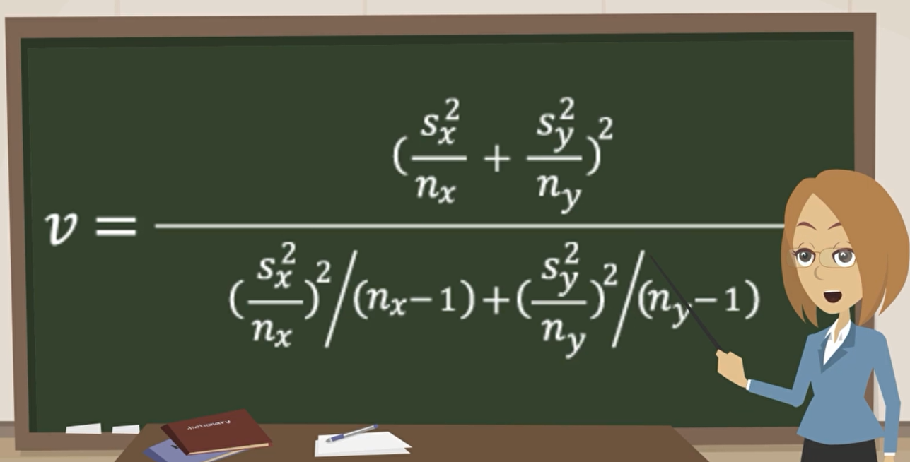

the tough things about this is to estimate the degrees of freedom. statisticians have come up with a formula that allows us to do just that